EYFS- Yearly Overview

 | Mathematics
 | Nursery: Number through Stories  1: The Gingerbread Man 2.Little Red Riding Hood 3. Goldilocks/Three Little Pigs 4.Wizard of Oz 5. Hungry Caterpillar 6. Jack and the Beanstalk 7. Snow White  8.The Enormous Turnip 9. The Train Ride 10.Ten Little Series  Reception: Following Power Maths Scheme |  |  |  | End of EYFS
 | Number and Place Value | Addition and Subtraction | Properties of Shapes | Position, direction & pattern
Nursery | - Says number names to count objects, not necessarily in the right order  - Begin to develop one to one correspondence and say one number name for each object.  - Move or touch objects to count them (1-5)  - Knows that the last number reached when counting tells you how many there is in total.  - Count out specific number of objects from larger group (1-10)  - Knows number names initially to 5 then 10.  - Subitise small amounts arranged in regular pattern  - Uses language ‘more than’ ‘fewer than’ in real world situations.  - Recognises amounts that have been rearranged, if nothing has been added or taken away, then the amount is the same.  - Show ‘finger numbers’ up to 5  - Experiment with their own symbols and marks as well as numerals. | - Explore ways that numbers 0-5 can be represented i.e. 4 and 1.  - Solve real world mathematical problems with numbers 0-5. | - Explore 2D and 3D shape and their attributes through play such as construction, puzzles, shape sorters.  - Describes shapes using informal language such as ‘fat’ ‘pointy’ ‘corners’ ‘straight’ ‘flat’ ‘round’ | - Understands and describes position ‘in’ ‘on’ ‘under’  - Understands and uses direction words ‘up’ ‘down’ ‘across’  - Recognise and talk about an AB pattern i.e. red block, blue block, red block, blue block.  - Copy an AB pattern with range of features such as varying objects, size and orientation.  - Notice and correct an error in a repeating AB pattern | Number  Have a deep understanding of number to 10, including the composition of each number; 14 - Subitise (recognise quantities without counting) up to 5; - Automatically recall (without reference to rhymes, counting or other aids) number bonds up to 5 (including subtraction facts) and some number bonds to 10, including double facts.  Numerical Pattern  Verbally count beyond 20, recognising the pattern of the counting system; - Compare quantities up to 10 in different contexts, recognising when one quantity is greater than, less than or the same as the other quantity; - Explore and represent patterns within numbers up to 10, including evens and odds, double facts and how quantities can be distributed equally
Reception | - Counts to 30, forwards and backwards.  - Counts things that cannot be seen, touched or moved.  - Can say number before or after a number, dropping back to one.  - Can stop and start counting in different places (forwards & backwards)  - Subitise small amounts of objects arranged in irregular pattern.  - use the language of: equal to, more than, less than (fewer), most, least  - Compare numbers i.e. 8 is a lot bigger than 2 but 3 is only a little bigger than 2.  - Represent numbers using objects and marks.  - Create marks to represent numerals (1-10 then 1-20) | - Automatically recall number bonds for numbers 0-10  - Explore the composition of numbers to 10.  - read, write and interpret mathematical statements involving addition (+), subtraction (-) and equals (=) signs  - Record different ways a number can be partitioned (into 2 groups or more)  - solve additions and subtractions involving 1 digit numbers, using concrete objects and pictorial representations to support | - Explore properties of shapes through play including: curveness, numbers of sides/corners (2D) or edge, faces and vertices (3D)  - recognise and names some common 2-D and 3-D shapes. | - Understands and describes position ‘in front’ ‘behind’  - Understands and uses direction words ‘forwards’ ‘backwards’ ‘left & right’  - Recognise, talk about and continue an AB pattern then a more complex pattern such as ABC, ABB, ABBC, AABB.  - Notice and correct an error in a complex repeating pattern

Reception- Yearly Overview

 | Week 1 | Week 2 | Week 3 | Week 4 | Week 5 | Week 6 | Week 7 | Week 8 | Week 9 | Week 10 | Week 11 | Week 12
AUTUMN | Unit 1: Number and Place value-Numbers to 5 |  |  | Unit 2: Addition and Subtraction- Sorting | Unit 3: Number and Place value-Comparing groups within 5 |  | Unit 4: Addition and Subtraction- Change within 5 |  | Unit 5- Time | Consolidation
SPRING | Unit 6: Number bonds to 5 | Unit 7: Number to 10 |  | Unit 8: Comparing numbers within 10 | Unit 9: Addition to 10 | Unit 10: Number bonds to 10 |  | Unit 11: Shape and Space |  |  | Consolidation
SUMMER | Unit 12: Explore Patterns |  | Unit 13: Counting on and back |  | Unit 14: Numbers to 20 | Unit 15: Numerical Patterns |  |  | Unit 16 Measure: |  |  | Consolidation

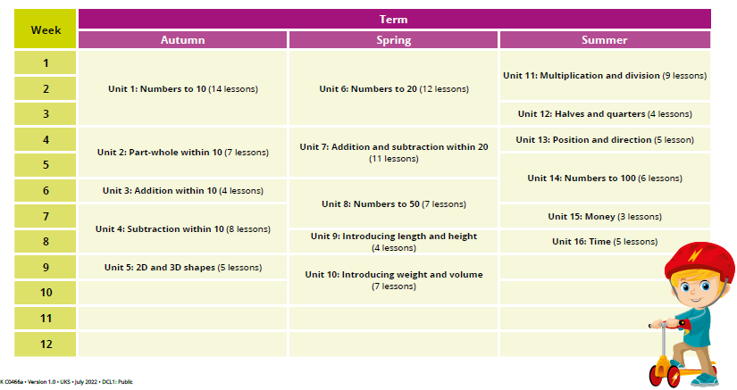

Year 1- Yearly Overview

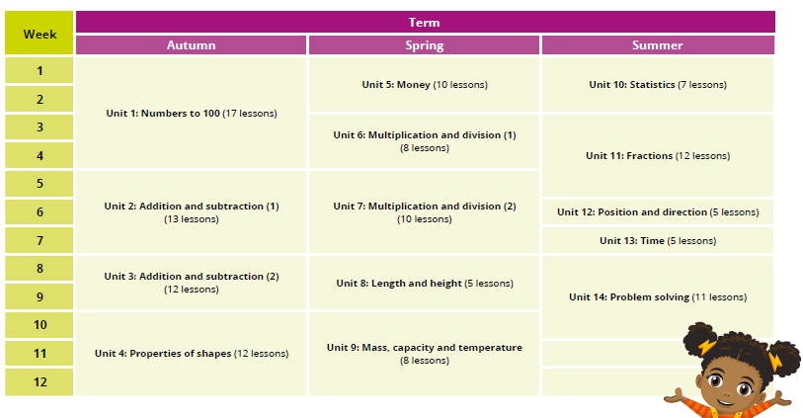
Year 2- Yearly Overview

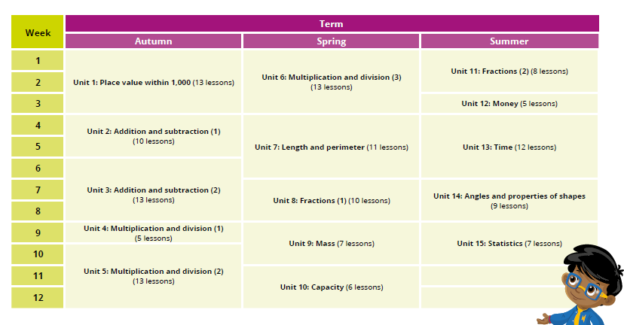

Year 3- Yearly Overview

Year 4- Yearly Overview

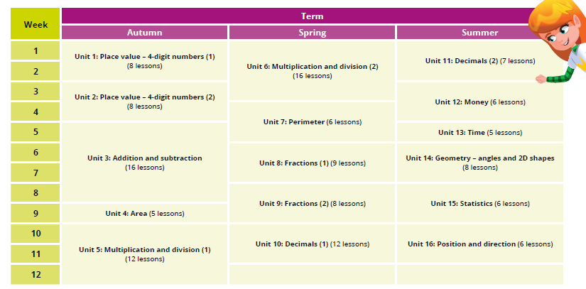

Year 5- Yearly Overview
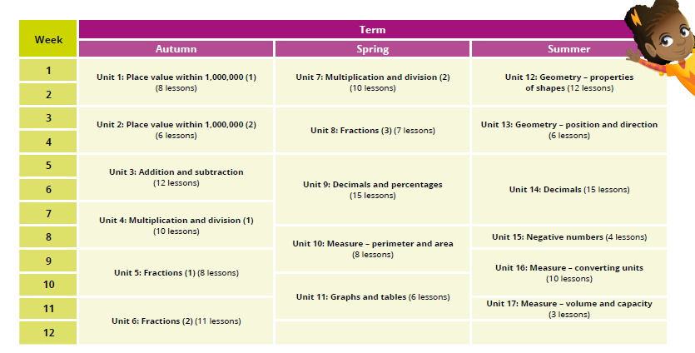

Year 6- Yearly Overview
