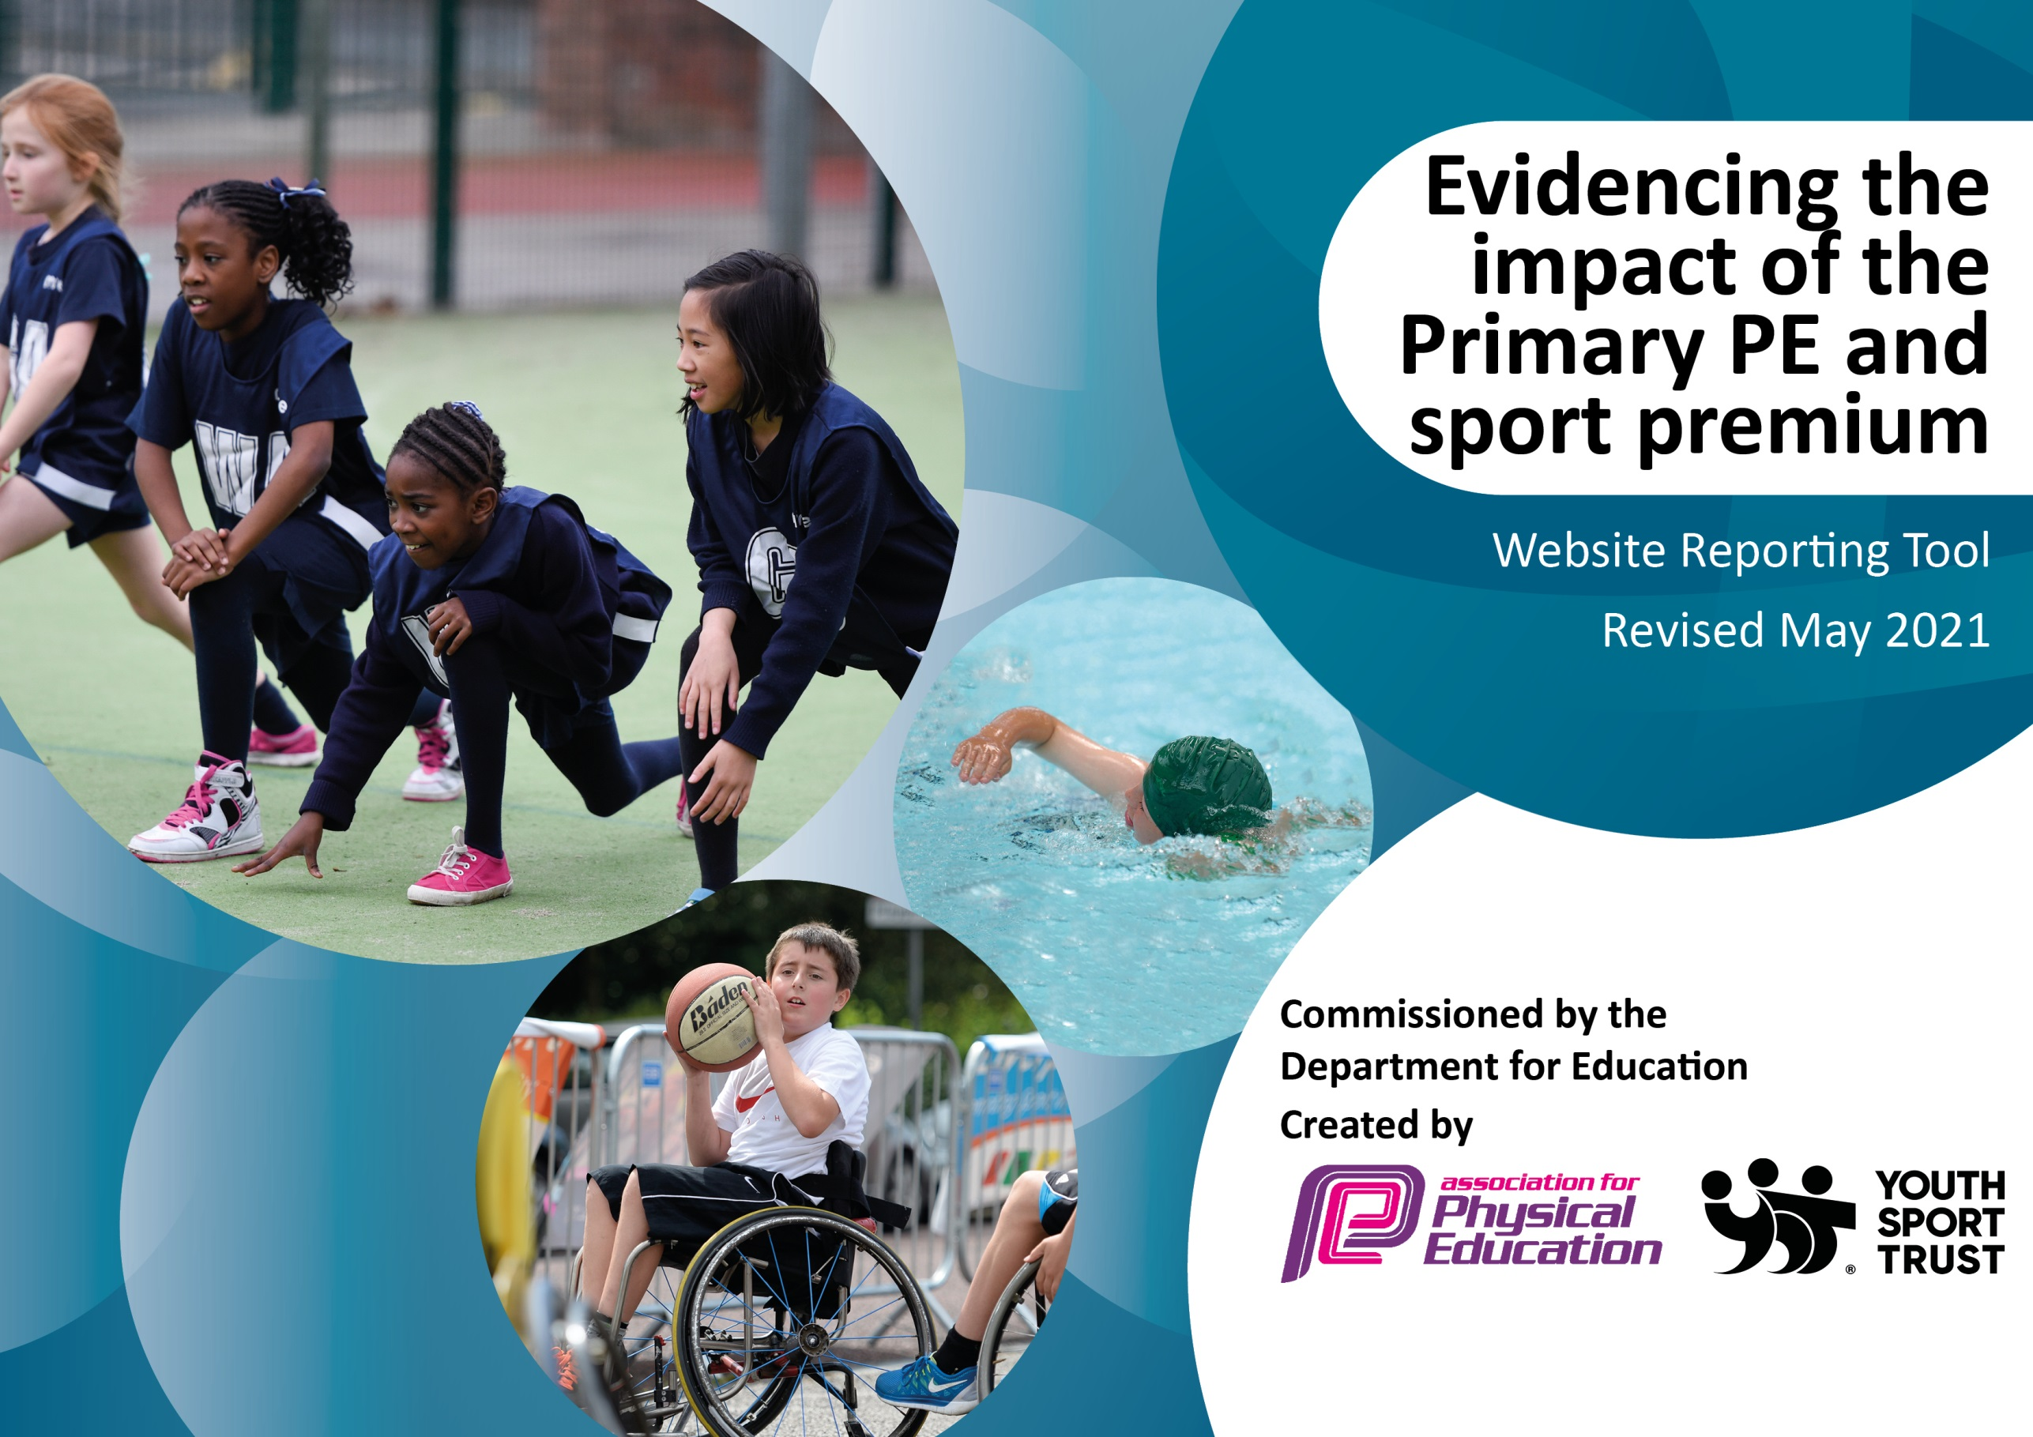

It is important that your grant is used effectively and based on school need. The Education Inspection Framework (Ofsted 2019 p64) makes clear there will be a focus on ‘whether leaders and those responsible for governors all understand their respective roles and perform these in a way that enhances the effectiveness of the school’.

Under the Quality of Education criteria (p41) inspectors consider the extent to which schools can articulate their curriculum (INTENT), construct their curriculum (IMPLEMENTATION) and demonstrate the outcomes which result (IMPACT).

To assist schools with common transferable language this template has been developed to utilise the same three headings which should make your plans easily transferable between working documents.

Schools must use the funding to make additional and sustainable improvements to the quality of Physical Education, School Sport and Physical Activity (PESSPA) they offer. This means that you should use the Primary PE and sport premium to:

- Develop or add to the PESSPA activities that your school already offer
- Build capacity and capability within the school to ensure that improvements made now will benefit pupils joining the school in future years
- The Primary PE and sport premium should not be used to fund capital spend projects; the school’s budget should fund these.
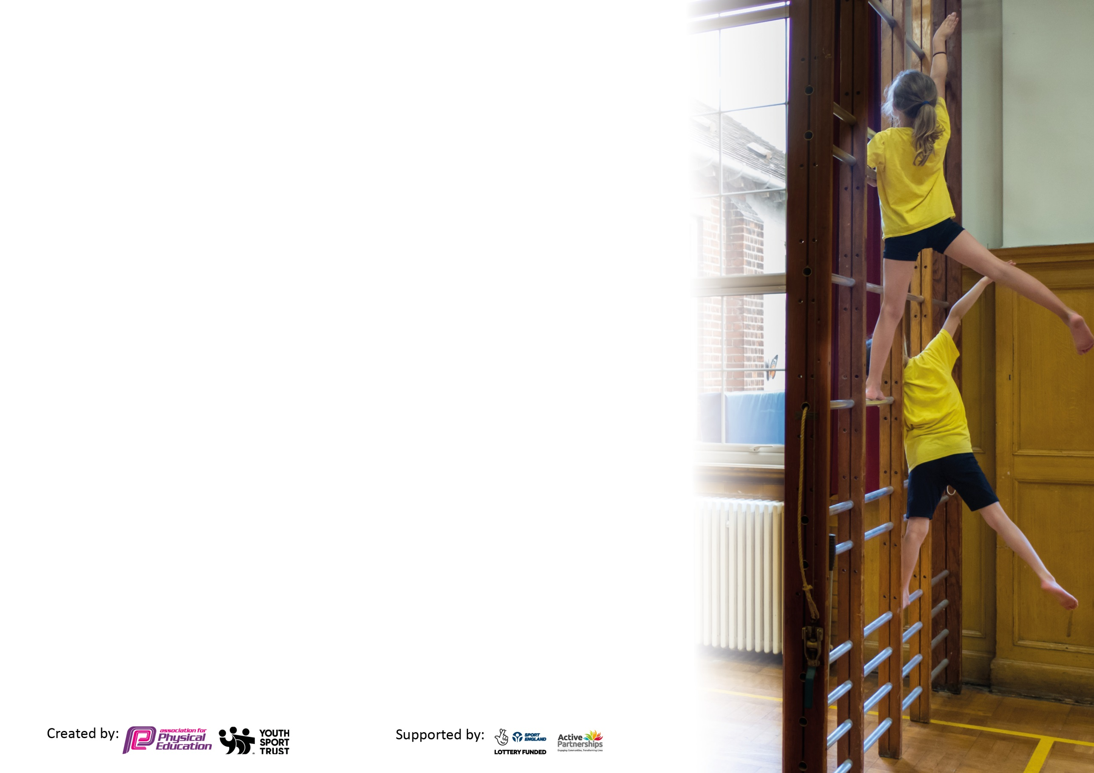
Please visit gov.uk for the revised DfE guidance including the 5 key indicators across which schools should demonstrate an improvement. This document will help you to review your provision and to report your spend. DfE encourages schools to use this template as an effective way of meeting the reporting requirements of the Primary PE and sport premium.

We recommend you start by reflecting on the impact of current provision and reviewing the previous spend.

Schools are required to publish details of how they spend this funding, including any under-spend from 2019/2020, as well as on the impact it has on pupils’ PE and sport participation and attainment by the end of the summer term or by 31st July 2021 at the latest.

We recommend regularly updating the table and publishing it on your website throughout the year. This evidences your ongoing self-evaluation of how you are using the funding to secure maximum, sustainable impact. Final copy must be posted on your website by the end of the academic year and no later than the 31st July 2021. To see an example of how to complete the table please click HERE.

Please note: Although there has been considerable disruption in 2020 it is important that you publish details on your website of how you spend the funding - this is a legal requirement.
Support for review and reflection - considering the 5 key indicators from DfE, what development needs are a priority for your setting and your pupils now and why? Use the space below to reflect on previous spend and key achievements and areas for development.

N.B. In this section you should refer to any adjustments you might have made due to Covid-19 and how these will influence further improvement.
Key achievements to date until July 2020: | Areas for further improvement and baseline evidence of need:
- Increased involvement in competitive sport (pre Covid)  - Increased options for children in after school clubs for sport  - Improvement in subject knowledge and delivery of P.E from staff  - Achieving Gold Games award  - Raised profile of P.E and sport across the school | - Reintroduce competitive sport following covid-19 restrictions  - Reintroduce after school sports clubs  - Continue to raise the profile of P.E across the school

Did you carry forward an underspend from 2019-20 academic year into the current academic year? YES/NO * Delete as applicable
Total amount carried forward from 2019/2020 £0
+ Total amount for this academic year 2020/2021 £17,705
= Total to be spent by 31st July 2021 £17,705

Meeting national curriculum requirements for swimming and water safety.

N.B Complete this section to your best ability. For example you might have practised safe self-rescue techniques on dry land which you can transfer to the pool when school swimming restarts.
Due to exceptional circumstances priority should be given to ensuring that pupils can perform safe self rescue even
if they do not fully meet the first two requirements of the NC programme of study.
What percentage of your current Year 6 cohort swim competently, confidently and proficiently over a distance of at least 25 metres?  N.B. Even though your pupils may swim in another year please report on their attainment on leaving primary school at the end of the summer term 2021.  Please see note above. | 48%
What percentage of your current Year 6 cohort use a range of strokes effectively [for example, front crawl, backstroke and breaststroke]?  Please see note above. | 31%
What percentage of your current Year 6 cohort perform safe self-rescue in different water-based situations? | 31%
Schools can choose to use the Primary PE and sport premium to provide additional provision for swimming but this must be for activity over and above the national curriculum requirements. Have you used it in this way? | No

Action Plan and Budget Tracking
Capture your intended annual spend against the 5 key indicators. Clarify the success criteria and evidence of impact that you intend to measure to evaluate for pupils today and for the future.

Academic Year: 2020/21 | Total fund allocated: £17,705 | Date Updated: 24.06.21
Key indicator 1: The engagement of all pupils in regular physical activity – Chief Medical Officers guidelines recommend that primary school pupils undertake at least 30 minutes of physical activity a day in school |  |  |  | Percentage of total allocation:
 |  |  |  | %
Intent | Implementation |  | Impact
Your school focus should be clear what you want the pupils to know and be able to do and about  what they need to learn and to  consolidate through practice: | Make sure your actions to achieve are linked to your intentions: | Funding allocated: | Evidence of impact: what do pupils now know and what can they now do? What has changed?: | Sustainability and suggested next steps:
- All children receive at least two of hours of P.E lessons every week through a combination of class teachers and sports specialists.  - After school sports clubs made available for all children from Y2-Y6 on a designated day.  - Daily mile to continue to be undertaken in order to promote physical and mental wellbeing around school as well as improve concentration levels in class.  - Physical activity at lunch time activities to be led by supervisors.  - Scootfit sessions introduced for each class. | - Through P.E lessons, ensure our children understand the role of movement in the development of their own physical literacy, fitness and well-being.  - Offer a wide variety of sports in after school clubs so that children are exposed to different activities rather than just a single sport they may not enjoy.  - Time to be given to the daily mile. Each class teacher to promote individually.  - CPD for supervisors to support lunch time games.  - Use Scootfit to promote an active lifestyle and a healthy mode of transport. | Total gymnastics lesson + after school club £3380  Merseyside multisport afterschool clubs £1170  Lunch time and other after school clubs £3785  Sports coach £7570  Scootfit funded outside Sports Premium. | 88% of children enjoying P.E lessons and being active throughout the school day as evidenced through pupil voice questionnaires.  73% of children enjoying afterschool clubs in sport and the variety of activities being offered as evidenced through pupil voice questionnaires and good attendance across classes.  Children across the school more active on a regular basis as demonstrated by amount of designated time given to P.E  90% of children feel active at lunch time as evidenced by pupil voice questionnaires.  Children extremely positive about the scootfit experience and excited for the next visit as evidenced by pupil voice – 87% | Staff continue to develop CPD through working in coordination with sports coaches to plan and deliver P.E lessons.  Every child to be given the new school P.E kit free of charge to ensure all children have appropriate clothing to participate in physical activity.  Train up children to be playground leaders once restrictions are relaxed and it is safe to mix between bubbles. Children will then lead play activities at lunch time.
Key indicator 2: The profile of PESSPA being raised across the school as a tool for whole school improvement |  |  |  | Percentage of total allocation:
 |  |  |  | %
Intent | Implementation |  | Impact
Your school focus should be clear what you want the pupils to know and be able to do and about  what they need to learn and to  consolidate through practice: | Make sure your actions to achieve are linked to your intentions: | Funding allocated: | Evidence of impact: what do pupils now know and what can they now do? What has changed?: | Sustainability and suggested next steps:
- Raise the profile of P.E throughout the school by updating staff, children and parents with information on what is happening within the subject.  - Teachers and TAs to take part in daily mile to promote the importance of staying active throughout the day.  - School staff to be confident in delivering their own P.E lessons due to CPD they have received through sports coaches.  - Use P.E lessons to make cross curricular links. Science to measure impact exercise has on heart rate. Maths to measure distance ran, jumped and thrown etc.  - Ensure all children are taught the importance of a healthy lifestyle which includes regular exercise and healthy eating.  - Use qualified sports coach to introduce physical sensory activities for children who would benefit from this. | Weekly updates on the school newsletter to update on participation and achievements within lessons and competitions. Twitter to be used to post photos and updates of sporting activities taking place inside and outside of school. Notice board in school will also be used to promote P.E.  Staff to work alongside qualified sports coaches to help improve their own delivery of P.E and to implement outstanding practice across the school.  Discussion in staff meetings to consider other areas where physical activity can be promoted. Identify opportunities within other subjects for P.E to be used to help make children more active throughout the day.  Each class to discuss the importance of being healthy. Lesson to be taught on identifying what is a healthy food and what isn’t. Fruit to be sold daily as a break time snack.  Qualified sports coach to undergo training in physical sensory activities. Identify children who would benefit from time out of class to complete such activities in an effort to improve concentration and focus. | Sports coach £7570 | Pupils and parents have an increased awareness of what happening is happening around school with regards to P.E. They know about competitions the school has participated in and commented favourably the video produced for sports day due to parents being unable to attend in person.  Staff increased in levels of confidence in their own ability to deliver P.E lessons. Increased levels of responsibility and awareness of the importance in the subject and how to deliver outstanding practice.  Book scrutinies show cross curricular links being made with P.E. In Year 6 the children enjoyed monitoring the difference in their heart rate following various physical activities. Overall, more opportunities are being given for children to be physically active across the school day.  Children across school more informed about what reflects a healthy diet and why it is important to consume fruit and vegetables regularly.  Children with sensory needs benefiting from physical sensory activity. Class teachers commenting upon an increased amount of concentration and engagement in class. | Continue to develop P.E display and update regularly with useful information around the subject.  Staff to continue to work in coordination with sports coach and consult on teaching ideas to improve their own ability in delivering lessons.  Introduce professional/semi professional athletes to the children (covid regulations permitting) to inspire the children to participate more in sporting activities.  Continue to build upon the progress in this area. Train up other members of staff so they can deliver sensory activities to more children across the school.

Key indicator 3: Increased confidence, knowledge and skills of all staff in teaching PE and sport |  |  |  | Percentage of total allocation:
 |  |  |  | %
Intent | Implementation |  | Impact
Your school focus should be clear | Make sure your actions to | Funding | Evidence of impact: what do | Sustainability and suggested
what you want the pupils to know | achieve are linked to your | allocated: | pupils now know and what | next steps:
and be able to do and about | intentions: |  | can they now do? What has
what they need to learn and to |  |  | changed?:
consolidate through practice:
- Raise the quality of teaching and learning in P.E throughout the school. Ask staff what they feel they need in order to improve their teaching of the subject.  - Subject leader to monitor the effectiveness of teaching and the impact it is having upon the children.  - Qualified sports coaches to work with lunch time supervisors to support games and activities. | - Subject leader and qualified sports coach to lead CPD opportunities for staff throughout the year.  - Use staff meetings to look at progression map across different areas of P.E so that staff are confident of how to structure planning.  - Staff to observe qualified sports coach and implement outstanding practice they have observed into their own teaching.  - Use staff feedback to tailor meetings towards what staff feel they need to improve their ability to deliver quality P.E lessons  - Subject leader to observe lessons to assess the impact of P.E within the school upon the children | Sports coach  £7570 | Children enjoying P.E lessons which are being led confidently by staff.  Children benefiting from improved standard of P.E being delivered by staff that have increased subject knowledge and understanding.  Staff benefiting from having access to sports coach to discuss ideas surrounding sequencing lesson planning. This has helped to improve the standard of progression and learning for children within a sequence of lessons.  Children enjoying lunch times due to the play being more structured play. | Continue to use sports coach to support teaching of P.E throughout the school next year.  Continue to deliver relevant CPD to staff following consultation on areas they feel they would like support in.
Key indicator 4: Broader experience of a range of sports and activities offered to all pupils |  |  |  | Percentage of total allocation:
 |  |  |  | %
Intent | Implementation |  | Impact
Your school focus should be clear | Make sure your actions to | Funding | Evidence of impact: what do | Sustainability and suggested
what you want the pupils to know | achieve are linked to your | allocated: | pupils now know and what | next steps:
and be able to do and about | intentions: |  | can they now do? What has
what they need to learn and to |  |  | changed?:
consolidate through practice:
- Ensure children are exposed to a wide variety of sports.  - Purchase necessary equipment for children to be able to take part in a wider variety of sports.  - Use after school clubs as a driving force once Covid restrictions have been lifted to give children a broader experience across a wide range of sporting activities. | Plan with sports coaches and class teachers which sports and physical activities will be covered at different times of the year in order to ensure children are being given the opportunity to develop across a wide range of areas.  Purchase the required equipment to cover all sports and activities that will be taught in school across the academic year.  Plan with the sports coach different activities which can be covered in the after school club to ensure the children aren’t participating in a narrow range of sports.  Consult with the children to discuss which activities they would like to participate in during after school clubs. | £500 P.E resources  £7570 Sports coach | Children enjoyed a wide P.E curriculum covering different activities throughout each half term. 86% of children agree with the statement that they learn about a lot of different sports.  High numbers of children attending after school clubs in a variety of sports to catch up on lost physical activity due to Covid restrictions.  Children enjoying the opportunity to participate in a variety of after school sports. Children now engaged with a variety of sports they otherwise wouldn’t have been – understanding the rules and improving their skills in these different areas. | Take forward the after school clubs for each year group from Y2-Y6 next year so we can continue to catch up for lost physical activity during lockdown.  Listen to pupil voice when considering which sports to cover in the after school clubs for the following year.  Purchase the necessary equipment for sports we wish to cover for the next academic year.

Key indicator 5: Increased participation in competitive sport |  |  |  | Percentage of total allocation:
 |  |  |  | %
Intent | Implementation |  | Impact
Your school focus should be clear | Make sure your actions to | Funding | Evidence of impact: what do | Sustainability and suggested
what you want the pupils to know | achieve are linked to your | allocated: | pupils now know and what | next steps:
and be able to do and about | intentions: |  | can they now do? What has
what they need to learn and to |  |  | changed?:
consolidate through practice:
- Enter virtual competitions at the beginning of the year due to the impact of Covid 19.  - When the situation improves, enter competitions through KSSP so children can once again be involved in competitive sport.  - Think carefully about which children would benefit most from being involved in the competitions.  - Ensure markings are laid out on school field in order to be hold a prospective sports day if Covid situation improves. | Endeavour to ensure as many children have the opportunity to participate in competitive sport as possible.  Hold sports day if possible in order to give all children the opportunity to compete against class mates.  Enter as many competitions as the school calendar allows in order to ensure as many children as possible have the chance to participate. | £1300 KSSP competitions | Children enjoyed competing in sports day as evidenced from feedback – 86%  In the limited number of competitions the school managed to compete in due to Covid restrictions, children relished the opportunity to apply skills they have learned in P.E in a competitive environment.  Children who said they had never been to a competition before were selected and they enjoyed their experience. | Due to the impact of Covid and the disruption it has caused to school competitions, next year will be a priority to enter as many competitions as possible.  Plan for class competitions in the event that Covid once again causes disruption in this area.  Develop the idea of beating personal bests in the daily mile.

Signed off by
Head Teacher:
Date:
Subject Leader:
Date:
Governor:
Date:

