‘To educate the children and serve the community, in the love of Jesus Christ’
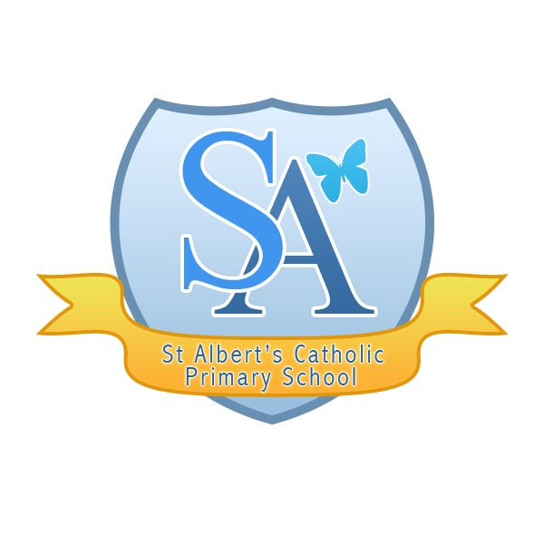
Art, Craft and Design Policy
Art Lead: Brittany FLeming

Date: May 2021

INTRODUCTION

Art, craft and design stimulates creativity, imagination and embodies some of the highest forms of human creativity; providing visual, tactile and sensory experiences. It is a way for the children to communicate what they see, feel and think. They learn to make informed value judgements and aesthetic and practical decisions. This area allows them to explore ideas and meanings in the work of artists, craftspeople and designers and to learn about the diverse roles and functions of art, craft and design in contemporary life and in different times and cultures.
AIMS
- To develop creativity and imagination
- To develop an understanding of colour form texture and pattern
- To develop the ability to use materials and processes to communicate ideas and feelings
- To record from first hand experience and from imagination
- To explore ideas and meanings in the work of artists, designers and craftspeople
- To understand, appreciate and enjoy visual arts
- To use a variety of tools and techniques with increasing confidence and independence
- To work with enjoyment and commitment
- To take pride in personal achievement and appreciate the work of others through displays
- To learn about the diverse roles and functions of art, craft and design in contemporary life and in different times and cultures
- To extend and enrich other curriculum areas through art and design

OBJECTIVES

Pupils should be taught to:
- Produce creative work, exploring their ideas and recording their experiences
- Become proficient in drawing, painting, sculpture and other art, craft and design techniques
- Valuate and analyse creative works using the language of art, craft and design
- Know about great artists, craft makers and designers, and understand the historical and cultural development of their art forms.

By the end of each key stage, pupils are expected to know, apply and understand the matters, skills and processes specified in the relevant programme of study.

ORGANISATION AND PLANNING

Foundation Stage

Creativity is fundamental to successful learning. The creative development of the children is related to the objectives set out in the Early Learning Goals, which includes art, music dance, role-play and imaginative play. Being creative enables children to make connections between one area of learning and another and so extend their understanding.

Children should experience:
- A stimulating environment in which creativity, originality and expressiveness are valued
- A wide range of activities that they can respond to by using their senses
- Time to explore, develop ideas and finish tasks
- The opportunity to express their ideas through a wide range of types of representation

Key Stage 1

During KS1 pupils learn to develop their creativity and imagination by exploring the tactile and sensory qualities of materials and processes. They begin to understand the eight elements of art and use them to represent ideas and feelings

Children should be taught knowledge, skills and understanding through:

- Creating sketch books to record their observations and use them to review and revisit ideas
- using a range of materials creatively to design and make products
- using drawing, painting and sculpture to develop and share their ideas, experiences and imagination
- developing a wide range of art and design techniques in using colour, pattern, texture, line, shape, form and space
- investigating the work of a range of artists, craft makers and designers, describing the differences and similarities between different practices and disciplines, and making links to their own work.

Exploring and developing ideas

Pupil should be taught to:

- Record from first hand observation, experience and imagination, and explore ideas.
- Ask and answer questions about starting points for their work and develop their ideas

Investigating and making art craft and design

Pupils should be taught to:
- Investigate a range of materials and processes
- Use a range of tools and techniques and apply these to materials and processes
- Represent observations, ideas and feelings and design and make images and artefacts

Evaluating and developing work

Pupils should be taught to:

- Review what they and others have done and say what they think and feel about it
- Identify what they think they might change in their current work or develop in their future work

Knowledge and understanding

Pupils should be taught about:
- Visual and tactile elements, including colour, pattern and texture, line and tone, shape form and space
- Materials and processes used in art, and craft and design tasks
- Differences and similarities in the work of artists, craftspeople and designers in different times and cultures.

Key Stage 2

During KS2 pupils develop their creativity through more complex activities and developing their techniques, including their control and their use of materials, with creativity, experimentation and an increasing awareness of different kinds of art, craft and design. They become more confident in using visual and tactile elements and processes to communicate what they see, feel and think. They increase their critical awareness of the roles and purposes of art, craft and design in different times and cultures. They will build on the skills and techniques developed in KS1.

Children should be taught knowledge, skills and understanding through:
- Creating sketch books to record their observations and use them to review and revisit ideas
- Improving their mastery of art and design techniques, including drawing, painting and sculpture with a range of materials [for example, pencil, charcoal, paint, clay]
- Investigating great artists, architects and designers in history.

Exploring and developing ideas

Pupil should be taught to:
- Select and record from first hand observation
- Make thoughtful observations about starting points and select ideas to use in their work
- Collect visual and other information to help them develop their ideas, including using a sketch book

Investigating and making art craft and design

Pupils should be taught to:

- Investigate and combine visual and tactile qualities of materials and processes and to match these qualities to the purpose of the work
- Apply their experience of materials and processes, including drawing and developing their control of tools and techniques.
- Use a variety of methods and approaches to communicate observations, ideas and feelings

Evaluating and developing work

Pupils should be taught to:

- Compare ideas
- Adapt work according to their views and describe how they might develop it further

Investigating and making art craft and design

Pupils should be taught:
- How visual and tactile elements can be combined and organised for different purposes
- How materials and processes can be matched to ideas and intentions
- The roles and purposes of artists, craftspeople and designers working in different times and cultures

Pupils should be encouraged to:
- Respect their own work and that of other pupils
- Use materials and tools safely
- Enjoy what they are doing
- Investigate and experiment with confidence
- Value high standards of workmanship and design
- Consider their own attitudes and values in relation to images and artefacts and learn to challenge assumptions, stereotypes and prejudice in visual and other forms
- Value the natural and man-made environment

PUPILS RECORDED WORK

Art, craft and design is a practical subject which can be expressed in many forms. The children should have as many different experiences as possible. Cross curricular links will create an exciting way to develop children as artists. Displays of work will be evident around the schools. Photos of work and videos of children at work will also provide evidence.

RESOURCES
There is a central store in the Art cupboard. Each classroom will have a basic supply of art materials e.g. paint, pastels etc. Each year the art and design co-ordinator will purchase what is required after consultation with staff.
ASSESSMENT AND RECORDING
Formative assessment will be on going via discussions and observations made by the teacher during art lessons. Assessments will be based on the individual child’s success in achieving the learning objectives for their lessons. Teachers may use evaluative comments, written or verbal to note achievement and areas for further development. Assessment is based on the NC level descriptions. Artwork may be photographed and retained as evidence in sketchbooks .
INCLUSION AND PUPILS WITH SPECIAL NEEDS.
Children are integrated into classroom activities, having the same access to the curriculum. Children at either end of the spectrum will be catered for in planning. Some physical disabilities may impinge on certain areas of study; strategies will be employed in order to overcome them.
ICT
All classes have interactive white boards which can be used to view works of art. Power points can be used to show slide shows of artists work and to compare and contrast different artists and art forms.

MONITORING

The Art and Design co-ordinator will monitor the subject throughout the school and provide a written report based on planning and any other evidence. The Art and design Co-ordinator if required will offer support.

