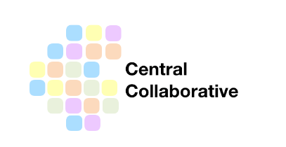
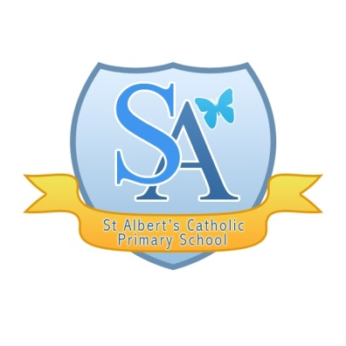

IMPORTANT INFORMATION REGARDING GOVERNMENT PLAN FOR SCHOOL OPENING

Dear Parents and Carers
As a group of schools forming the Central Collaborative we are writing to you following the Prime Minister’s statement last night. We are sure, like us, you have lots of questions which require further clarification. At the moment, for us in school, there is no change to the original guidance. We will provide care for those parents whose work is critical to the COVID19 response and only those who cannot be cared for safely at home. The message is still that is safer to stay at home.

We have not received any information to support us with this new plan to start the phased reopening of some year groups. We expect we will receive further information from the Department for Education shortly, hopefully with some clarification.

We will need clear guidance to plan how it is possible to socially distance in schools and keep our children, teachers and families safe; how we might start to phase groups of children returning and what this looks like. Please be assured we will not reopen to any new groups of children until we are 100% prepared.

As always, we will keep you informed but for now, please try not to worry. Our plan for now is to continue to provide activities for learning at home, keep contact with you, our children and families, and continue to support each other in these very difficult and uncertain times.

Warmest regards

Mrs McEvoy
Headteacher
St Albert’s Catholic Primary School

