St Albert's Catholic Primary School
Steers Croft Stockbridge Village Liverpool L28 8AJ
Te1 0151 477 8560 Fax 0151 477 8561 emai1 stalbert@knowsley.gov.uk
Headteacher Mrs L McEvoy
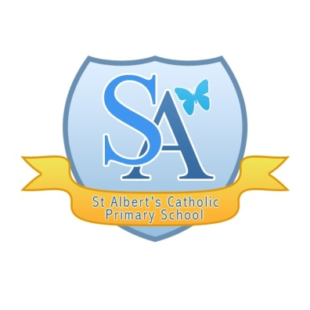
“Walking together with Jesus to Love, Learn and Serve”

Sunday 22nd March 2020

School access for vulnerable pupils and children of key workers

Dear Parent/Carer,

Following our letter/conversation, your child has now been allocated a place at school during this time of national crisis. They will only attend during the times that you are in work and unable to care for them yourself and you must inform school of these times in an email. ie Mon– place needed as in work, Tue- no place needed as a parents home, etc.

Please note that we need to restrict the number of places so that the provision can be safe and, therefore, children should only be in school if it is ABSOLUTELY necessary and no other arrangements can be made.

You must now guarantee that you are following all aspects of the Public Health England guidelines, including:

➢ Staying indoors when not working (key workers) or shopping for food / medicine
➢ Staying away from family and friends

If this applies to you, you must also guarantee that you are restricting the movements of your older children and ensuring that they do not meet up with friends.

Places will be withdrawn if I find that your child has been exposed to adults/young people who are not following the advice to distance yourself socially.

At school, we will be running a skeleton staffing system – as far as practicable, there will be a limited number of adults on site at any one time.

On arrival at school, please buzz in as you normally do during school hours at the school gate. A member of staff will greet your child at the entrance and direct them into school – you must leave your child at the gates and staff will guide them in to the class. Collection arrangements will run in a similar way. You will buzz in and be directed around to the area where your child is based and the children will come out of the door.

Please note that school does not start until 8.55am, unless your child usually accesses breakfast club, and children should not arrive before then as the gates will not be open and we do not want groups congregating Breakfast club will open at 8am prompt and children will need to be there for between 8 and 8,10am otherwise there will be no one available to collect your child and put them in the provision.

Every child MUST be collected at 3.15pm.

Please ensure your child has their own water botte with them.

At present, children will be in school uniform for ease but this may change.

If children fall ill, they must be picked up immediately.

Please be aware that the provision will be reviewed on a daily basis and could be subject to rapid change dependent on national guidance.

If our numbers are not within the safety parameters, we will apply a tier list to the key workers.

This is an emergency provision not child-care.

Thank you for your support. We are trying to ensure that the provision is accessed only by those in need to keep everyone as safe as possible.

Yours sincerely,

Mrs L McEvoy
(Headteacher)

