7 Minute Animal Themed HIIT Workout for kids - helps improves emotional regulation and reduce meltdowns.
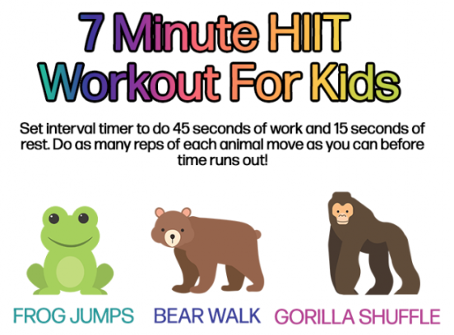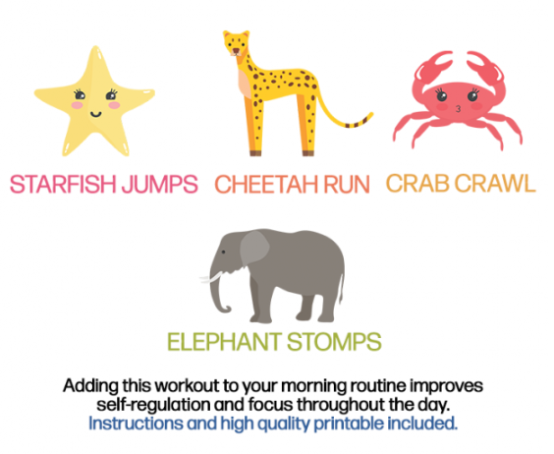

Frog Hops
These are exactly what they sound like. Hop back and forth, like a frog. Depending on how much room you have, you may need to hop in one place.

Bear Walk
Place your hands and feet on the floor. Your hips and bottom should be in the air, higher than your head. On all fours take two steps forward and two steps back, then repeat.

Gorilla Shuffles
Sink down into a low sumo squat and place your hands on the ground between your feet. Shuffle a few steps to the left and then back a few steps to the right. Maintain the squat and ape-like posture through the entire movement.

Starfish Jumps
These are jumping jacks! Do as many as you can, arms and legs spread wide like a starfish!

Cheetah Run
Run in place, as fast as you can! FASTER!

Crab Crawl
Sit with your knees bent and place your palms flat on the floor behind you near your hips. Lift your body off the ground and “walk” on all fours forward and then backward.

Elephant Stomps
Stand with your feet hip-width apart and stomp, raising your knees up to hip level, or as high as you can bring them up. Try to hit the palm of your hands with your knees.

Now you’re done!
Take some time to cool down slowly.
Do some stretches or yoga poses and allow your heart rate to return to normal. Those 7 minutes will give you and your kiddos a boost that will leave you feeling great for hours!
The animal theme makes this work out enjoyable for kids. Encourage them to use their imagination and make this work out feel like play.

