St Albert's Catholic Primary School
Steers Croft Stockbridge Village Liverpool L28 8AJ
Te1 0151 477 8560 Fax 0151 477 8561 emai1 stalbert@knowsley.gov.uk
Headteacher Mrs L McEvoy
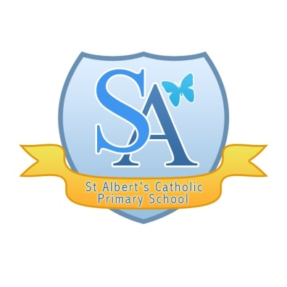
“Walking together with Jesus to Love, Learn and Serve”

A message from Knowsley LA:

Guidance for Parents/Carers whose child is in receipt of a FREE SCHOOL MEAL

Children still attending schools

If your child is still attending school as they are the child of a key worker or are they meet the criteria set out by the Government then they will still be provided with a free school meal from the school that they are attending on the days that they attend. All school kitchens remain open.

Support for Pupils who have to stay off

The Government is still developing a national voucher scheme that will be rolled out. At the current time the date for this hasn’t been confirmed. But further details of how this will work will be announced shortly. It is likely to be a food voucher for £10 a week but again we are awaiting details of this. Any applications for food vouchers will need to be done via your schools directly who will issue you with a voucher. This will be in the form of a physical voucher or an e-voucher but again we are still awaiting guidance on this scheme. Your school will inform you when this is available?

What should I do in the interim period?

The school meals service has made provision to cater for all Children who are entitled to a free school meal from Monday 23 March 2020 until the national scheme is launched. Packed lunches will be available for distribution from the following children’s centres:

SVP Community Hub, The Withens, Stockbridge Village, L28 1 AB (collect from the door)

The Star Children’s Centre, St Andrew’s View Tower Hill, Kirkby, L33 1ZF

The Eden Children’s Centre, Westvale Primary School, Melverley Road Westvale, Kirkby, L32 0RQ

The Pride Children’s Centre, 2 Simonswood Lane, Kirkby, L33 5YP

Jubilee Children’s Centre, Twig Ln, Huyton, Liverpool, L36 2L

Hilltop Children’s Centre, Bedford Close, Huyton, L36 1XH

Southmead Children’s Centre, Sherwood Drive, Whiston, L35 3XZ

New Hutte Children and Families Hub, Lichfield Rd, Halewood, Liverpool, L26 1TT

What shall I do if my family and I are self–isolating?

When the voucher scheme is set up it is expected that electronic vouchers will be issued and you will can receive these through your mobile phone or computer but we are still waiting on further details on that from the Government.

Whilst we are waiting for that think about whether there anyone else who can collect the meal(s) on your behalf.

The Council has launched a new Coronavirus Community Support and Volunteer Line. The helpline number is 0800 073 0043 and is for residents to use to ask for help and advice. We are working to build a team of volunteers who you may be able to use to deliver lunches whilst you are self-isolating.

What if my Child is in a School outside Knowsley?

If you attend a school that is Out of Borough you need to contact your school as they might have made alternative arrangements.

PLEASE CONSIDER THE NEEDS OF ALL WHEN COLLECTING FREE SCHOOL MELAS AND OBERVE SAFETY AND ISOLATION ADVICE

Here are some useful links to other organisations providing support

https://knowsley.foodbank.org.uk/ - Knowsley Foodbank
https://www.facebook.com/kirkbystorehouse - Kirkby foodbank

