St. Albert’s and St. Brigid's
CATHOLIC Primary Schools

complaints Policy

Date adopted by governing body - 2nd November 2011

Chair of Governors Mr Chris O’Connor

Executive Headteacher – Mrs Rachael Tyler

Associate Headteacher - Mrs Lorraine McEvoy

To be reviewed annually

Signed ______________________ Chair of Governors
contents

Introduction……………………………………………………………………………3

Linked Documents……………………………………………………………………4

Anonymous Complaints……………………………………………………………..4

Publication…………………………………………………………………………….4

Informal Stage………………………………………………………………………..5

Formal Procedures
Stage One…………………………………………………………………………….7
Stage Two…………………………………………………………………………….9
Stage Three………………………………………………………………………….11

Withdrawing a complaint…………………………………………………………...11

Dealing with unreasonable and unreasonably persistent complaints…………11
Examples of unreasonable and unreasonably persistent complaints…………11
Things to consider……………………………………………………..……………12
Dealing with abusive, threatening or violent adult visitors……………………...13

Process Maps
Informal Stage……………………………………………………………………….14
Formal Stage One…………………………………………………………………..15
Formal Stage Two…………………………………………………………………..16
Formal Stage Three…………………………………………………………………17
Unreasonable and unreasonably persistent complaints………………………..18

Introduction

Since September 2003 governing bodies of all maintained schools and maintained nursery schools in England were required under section 29 of the Education Act 2002 to have in place a procedure to deal with complaints relating to the school and any community facilities or services that the school provides and to publicise the procedure.

This document is the Complaints Procedure for St Albert’s & St Brigid’s Schools

A complaint is defined as:
“An expression of dissatisfaction about a school or staff member, which requires a response.”

Pupils, parents or carers can make a complaint to the school about most aspects of its function including:
- Attitude / behaviour of staff
- Teaching and learning
- Application of behaviour management systems
- Bullying
- Provision of extra-curricular activities
- The school environment

The Local Authority retains responsibility for:
- The National Curriculum
- Collective Worship in schools (In the case of denominational schools, concerns relating to worship and spiritual matters may be referred to the relevant Diocese or Archdiocese.)
- Provision of support services such as SEN, school attendance, educational psychology.

Complaints about these matters should be referred to the Directorate of Children and Family Services via the Complaints Manager for progression through the council’s complaints procedure.

Members of the general public may make complaints to the school if the school is directly responsible for the issue being complained about. For example:

- Behaviour of pupils during break-times
- Disturbance to neighbours during school hours
- Health and Safety issues of premises
- Behaviour of staff

Legal, child protection or disciplinary proceedings take precedence over complaints procedures and timescales.

Schools are not responsible for the action and behaviour of pupils outside school hours.

Linked Documents

This document brings together guidance, policies and procedures relating to school complaints building on national guidance and best practice. This forms part of DCFS wider policy and procedures for complaints covering school complaints, corporate complaints and Children’s Act complaints (Children’s social care).

Variations to the procedure

If the complaint involves the Headteacher/Principal or a governor, the complainant should submit their complaint to the Chair of Governors, c/o the Clerk to Governors at the school.

If the complaint involves the Chair of Governors, the complainant should submit the complaint to the Vice-Chair of Governors, c/o the Clerk to Governors at the school.

Anonymous Complaints

Anonymous complaints must be recorded and referred to the Headteacher in the same way as other complaints.

The Headteacher should discuss anonymous complaints with the DCFS Complaints Manager. If there is sufficient information contained in the complaint it will be investigated in the same way as other complaints.

If there is insufficient information to support an investigation, the complaint will be recorded for service improvement purposes and closed.

Publication

There is a legal requirement for the Complaints Procedures to be publicised. The document will be publicised in the following locations:

School Reception Area – Admin Office

Informal Stage

The vast majority of concerns can be resolved informally. There are many occasions where concerns are resolved straight away by the class teacher, office staff, Head of Year or the Headteacher, depending on whom the complainant first approaches. It is in everyone’s best interests that complaints are resolved at the earliest possible stage.

We want to ensure that potential complainants feel able to raise concerns with members of staff without any formality, either in person, by telephone or in writing. This allows staff to establish whether a person is asking a question, expressing an opinion or making a complaint.

The member of staff who deals with the initial contact will:

- Clarify the nature of the concern and re-assure the complainant that we want to hear about it.
- Resolve the concern immediately if the member of staff can do so.
- Record the enquiry and any agreements made, and notify the Headteacher.

We will respect the wish of a complainant who indicates they would have difficulty discussing their concerns with a particular member of staff, as far as is practically possible. Similarly, if a member of staff feels too compromised to deal with a complaint, they can pass the concern to another member of staff.

Where the first approach is made to a governor, the next step will be to refer the complainant to the appropriate person and advise them about the procedure. Governors will not act on an individual complaint outside the formal procedure or be involved at the early stages as they may be required to sit on a review panel at a later stage of the procedure.

If the member of staff can’t resolve the concern, they will:

- Make a clear note of the date, name, contact address and phone number and a brief note of the nature of the concern.
- If possible, record the nature of the outcome the complainant is looking for.
- Refer the complaint to the Headteacher, or designated Deputy. The Headteacher, or designated Deputy will decide if the concern is covered by the complaints procedure or should be dealt with under other procedures e.g. child protection or personnel.

If the concern involves an allegation of assault or abuse of a child by a member of staff, the Headteacher/Principal must inform the Human Resources Manager.

If the concern is about the Headteacher, the member of staff will provide the complainant with details of how to contact the Chair of the Governing Body. (see also page 4 for other variations to procedure).

The staff member dealing with the concern will ensure that the complainant is kept informed of any action taken. The emphasis at this stage is on resolving the issue quickly and informally for the benefit of staff, pupils and parents / carers.

We will respond to the complainant as soon as possible, and within a maximum of 15 school working days. At this stage the response may be given verbally or in writing. A record will be kept to inform service improvement.

The complainant will be given information on how to proceed to more formal stages if they are not satisfied and where to get independent advice.

Formal Procedures - Stage One:

Formal complaints should be made in writing to the Headteacher. If the complaint is about the Headteacher it should be sent in writing to the Chair of the Governing body c/o Clerk to Governors at school address who should carry out this stage one procedure. If the complaint involves the Chair of Governors, the complainant should submit the complaint to the Vice Chair of Governors, c/o Clerk to Governors at school address.

If the complainant has difficulty expressing themselves in writing, they will be informed where they can get independent assistance. Template letters for making a complaint are available on request through the Parents / Carers Toolkit.

The Headteacher will acknowledge the complaint within five school working days. The acknowledgement will include a summary of the complaints procedure and a target date for providing a response. This should be within 15 school working days. If this date cannot be met, the complainant will be contacted and given a reason for the delay and a revised target date.

The Headteacher will provide an opportunity for the complainant to meet him/her to discuss their concerns and find solutions. It should be made clear that the complainant may bring a friend, family member or advocate (advocate is not allowed to be a legal representative) to the meeting if they wish. Interpreting services should also be made available where necessary. The Headteacher may wish to have another member of staff present to observe and record the meeting and promote staff safety.

We will take care to ensure we do not create an intimidating atmosphere for the complainant. Under no circumstances will audio recording equipment be used.

The Headteacher will make whatever enquiries s/he considers necessary to ascertain the facts and the legitimacy of decisions taken (the Headteacher may delegate the task of collating the information to another staff member but not the decision on the action taken). This may include:

- Interviewing staff / pupils
- Reviewing minutes of meetings
- Reviewing school records

Pupils will be interviewed in the presence of another member of staff or learning mentor, or in the case of serious complaints (e.g. where the possibility of criminal investigation exists) in the presence of their parents. Again, care will be taken in these circumstances not to create an intimidating atmosphere.

It is important that the Headteacher (or nominated officer) investigates complaints thoroughly and objectively. If s/he feels unable to do this (e.g. if s/he has been directly involved in the decision making process that led to the complaint) s/he will delegate responsibility for investigating the complaint to another member of the management team or the Chair of Governors. It is strongly advised that the Headteacher will keep a record of interviews, telephone conversations and other documentation.

Once all the relevant facts have been established, the Headteacher will provide a written response to the complainant. This will include:

- A full explanation of decisions taken and the reasons for them.
- Details of actions the school will take to resolve the complaint if appropriate.

If the Headteacher feels it is necessary and useful, s/he will offer the complainant a meeting to discuss the response and seek reconciliation.

The complainant will be provided with details of how to contact the Governing Body if they are not satisfied with the response.

In exceptional circumstances only, it may be appropriate for the Headteacher or Chair of Governors to commission another person to undertake the role of investigating officer on their behalf. This person could be a member of the school’s own governing body or an outside investigator. In either case, the investigating officer would be subject to the same rules of confidentiality and would be required to report back to the Headteacher or Chair of Governors as appropriate.

Formal Procedures - Stage Two

If the complainant is not satisfied with the outcome of Stage One and wishes to pursue matters to the next stage of the procedure, they should put this in writing no later than 28 school days after the outcome of Stage One was made known to them. However, if there are good reasons why the complainant cannot request that their complaint be considered at Stage Two within 28 days, further consideration will be given to allow them to do so.

A letter received by the school notifying that a complainant is dissatisfied with the outcome of a complaint at Stage One must be passed to the Chair of Governors within five school working days.

In the case of a written complaint received directly by the governing body, the Chair of Governors should first ensure that:

- The complaint has first been dealt with at Stage One.
- The complaint is covered by the school’s complaints procedure, not other procedures e.g. personnel or child protection.

Upon receipt of a letter notifying that the complainant is not satisfied with the outcome of a Stage One investigation, the Chair of Governors will arrange for a Complaints Appeal Panel to hear the complaint. However, in some circumstances, it may be possible and appropriate for the Chair of Governors to resolve the issue with the complainant without the need for a panel hearing.

The Clerk to the Governors will write to the complainant, acknowledging that the complaint has been received. The letter will explain that the complainant has the right to submit any further documents or information relevant to the complaint. A deadline for submission of these documents will also be given.

The Headteacher will also be invited to submit a written report for the complaints panel. The Headteacher may also invite members of staff directly involved in matters raised by the complainant to respond personally or in writing.

The Clerk to the Governors will convene the Complaints Panel elected from the governing body. The panel will comprise of three Governors who have had no previous involvement with the complaint. The complaint should not be heard by the entire governing body as this could compromise the impartiality of any panel set up for a disciplinary hearing against a member of staff following a serious complaint. The local authority will provide an Education Change Partner to act as an observer / mediator for any stage two complaints. This role will ensure a fair and equitable process is followed.

The complaints panel will set a timetable for the investigation and will notify the complainant of this. The review hearing should be heard within 20 school days of receiving the letter.

The Clerk will write to inform the panel, Headteacher, complainant and any relevant witnesses of the date and time of the hearing, giving a minimum of five school days notice. All documents submitted will be circulated to the panel, the Headteacher and the complainant. The complainant will be notified of their right to have a friend, family member, advocate (advocate is not allowed to be a legal representative) or interpreter present if they wish. The Chair of Governors will ensure that minutes are recorded of the review panel meeting.

The panel will be open-minded and independent. The aim of the meeting is to resolve the complaint and achieve reconciliation between the school and the complainant. However, it may sometimes only be possible to establish the facts and make recommendations that satisfy the complainant that their concern has been taken seriously.

The hearing will be held in private. Any witnesses (other than the complainant and the Headteacher) should only attend for the part of the hearing in which they give their evidence.

The Chair of the Panel will keep the proceedings as informal as possible as complainants may not be comfortable in formal meetings and may feel inhibited in addressing the panel. This is particularly important if the complainant is a child.

If either party wishes to introduce new information at the meeting, this will be allowed. The meeting will then be adjourned for a short period to allow other parties to review and respond to this information.

The meeting will allow for:

- The complainant to explain their complaint and the Headteacher to explain the school’s response.
- Witnesses to be brought by the complainant or the Headteacher.
- The Headteacher and the complainant to ask questions of each other and any witnesses.
- The Panel to ask questions of the complainant, Headteacher and any witnesses.
- The complainant and the Headteacher to summarise their position

The Chair of the panel will explain to the complainant and the Headteacher that the panel will consider its decision and respond in writing as soon as possible, but no later than within 15 school working days. The complainant and the Headteacher/Principal will then be asked to leave.

The panel will then consider the complaint and all the evidence presented. They will then decide:
- Whether or not they uphold the complaint, in whole or in part
- What action can be taken to resolve the complaint
- Where appropriate, recommend what action can be taken to prevent similar difficulties on the future.

A written response detailing the decisions, recommendations and the basis on which these have been made will be sent to the complainant as soon as possible but within a maximum of 15 school working days.

The school will retain a copy of all correspondence and records of meetings for seven years.
Formal Procedures - Stage Three

The Complainant will be notified of the right to appeal to the Secretary of State for Education or the Local Government Ombudsman if they are unhappy with the way in which procedures have been carried out.

Withdrawing a complaint

Complaints may be withdrawn in writing at any time.

The Headteacher and Chair of Governors should review the issue of concern and consider whether further investigation is required through other internal management systems.

Dealing with unreasonable and unreasonably persistent complaints

A good complaints procedure can limit the number of complaints that become protracted. However, there may be occasions when despite all stages of the procedure being followed, the complainant remains dissatisfied.

Unreasonable or unreasonably persistent complainants may have reasonable grounds for complaint but pursue them in unreasonable ways. Or they may pursue complaints which have no substance or have previously been investigated. Contact by such complainants with the school or authority may be amicable whilst placing significant demands on resources, or may be emotional and distressing for those involved.

Examples of unreasonable or unreasonably persistent complaints

The Local Government Ombudsman outlines a number of examples of unreasonable or unreasonably persistent complainants and the types of behaviour that may be encountered:
- Refusing to specify the grounds of a complaint, despite offers of assistance with this from staff.
- Refusing to co-operate with the complaints investigation process while still wishing their complaint to be resolved.
- Refusing to accept that issues are not within the remit of a complaints procedure despite having been provided with information about the procedure’s scope.
- Insisting on the complaint being dealt with in ways which are incompatible with the adopted complaints procedure or with good practice.
- Making what appear to be groundless complaints about the staff dealing with the complaints, and seeking to have them replaced.
- Changing the basis of the complaint as the investigation proceeds and/or denying statements he or she made at an earlier stage.
- Introducing trivial or irrelevant new information which the complainant expects to be taken into account and commented on, or raising large numbers of detailed but unimportant questions and insisting they are all fully answered.
- Electronically recording meetings and conversations without the prior knowledge and consent of the other persons involved.
- Adopting a 'scattergun' approach: pursuing a complaint or complaints with the authority and, at the same time, with a Member of Parliament, a local elected member, the authority’s independent auditor, the Standards Board, local police/solicitors/ or the Ombudsman.
- Making unnecessarily excessive demands on the time and resources of staff whilst a complaint is being looked into, by for example excessive telephoning or sending emails to numerous council staff, writing lengthy complex letters every few days and expecting immediate responses.
- Submitting repeat complaints, after complaints processes have been completed, essentially about the same issues, with additions/variations which the complainant insists make these 'new' complaints which should be put through the full complaints procedure.
- Refusing to accept the decision – repeatedly arguing the point and complaining about the decision.
- Combinations of some or all of these.

Things to Consider
In these circumstances, the Headteacher and / or Chair of Governors should liaise with Legal Services and the appropriate Children and Family Services Manager / Service Director before deciding what action to take. They may also seek advice from the Complaints Manager and Governor Support Service. In order to make use of the unreasonable or unreasonably persistent complaints procedure it should be clear and agreed that:
- the complaint is being or has been investigated properly;
- any decision reached on it is the right one;
- communications with the complainant have been adequate; and
- the complainant is not now providing any significant new information that might affect our view on the complaint.
The presumption should be in favour of not restricting access unless it is absolutely necessary. The Governors may consider:
- Warnings / contract regarding future conduct
- Suspension of the persons access to school premises
- Placing time limits on telephone conversations and personal contacts.
- Restricting the number of telephone calls that will be taken (for example, one call on one specified morning/afternoon of any week).
- Limiting the complainant to one medium of contact (telephone, letter, email etc) and/or requiring the complainant to communicate only with one named member of staff.
- Requiring any personal contacts to take place in the presence of a witness.
- Refusing to register and process further complaints about the same matter.
- Where a decision on the complaint has been made, providing the complainant with acknowledgements only of letters, faxes, or emails, or ultimately informing the complainant that future correspondence will be read and placed on the file but not acknowledged. A designated officer should be identified who will read future correspondence.

The complainant must be written to informing them of:
- the decision that has been taken;
- what it means for his or her contacts with the school;
- how long any restrictions will last; and
- how to contact the Local Government Ombudsman and Secretary of State.
A copy of the Complaints Policy must be enclosed with this letter.

Dealing with abusive, threatening or violent adult visitors
Schools should ensure that they have policies covering incidents involving abusive, threatening or violent adult visitors. These should include:
- What to do when an incident occurs: ask the person to leave, or invite them into a room away from other people
- Who to contact during an emergency: such as DCFS and the Police
- How to record incidents and who to report the incident to: visit http://publications.teachernet.gov.uk/eOrderingDownload/DfES-0504-2002.pdf for a model recording form.
- Follow-up action: any legal action to be taken, or if a parent whether they should be refused entry to the premises

- Support for the victim: counselling, occupational health and so on.
- Liaison with the police

As a general rule, schools are orderly, safe places, where relationships between staff and visitors, especially parents, demonstrate mutual respect and recognition of a shared responsibility for pupils’ welfare and educational progress. However, in a minority of schools, the behaviour of a few parents can cause severe disruption or worse, resulting in abusive or aggressive behaviour towards staff. Violence, threatening behaviour and abuse against school staff or other members of the school community will not be tolerated. All members of the school community have a right to expect that their school is a safe place in which to work and learn. There is no place for violence, threatening behaviour or abuse in schools. Where such behaviour does occur, the Directorate of Children and Family Services will play a proactive role in taking all possible action to deal with it, in response to the wishes of the school. If possible, the police should be involved in agreeing a policy for dealing with such incidents.

Process Maps

School Complaints Informal Stage

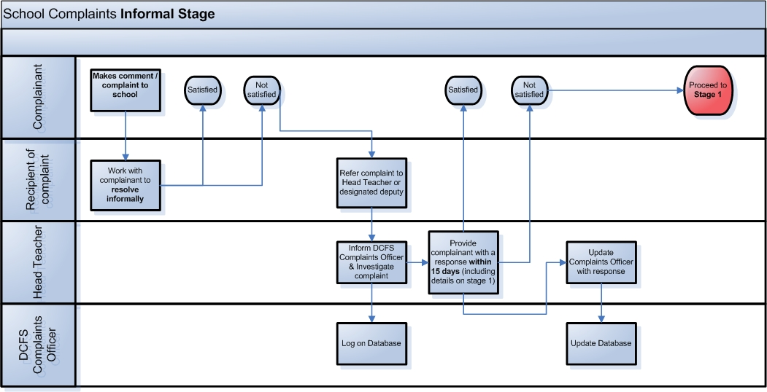

School Complaints Stage 1

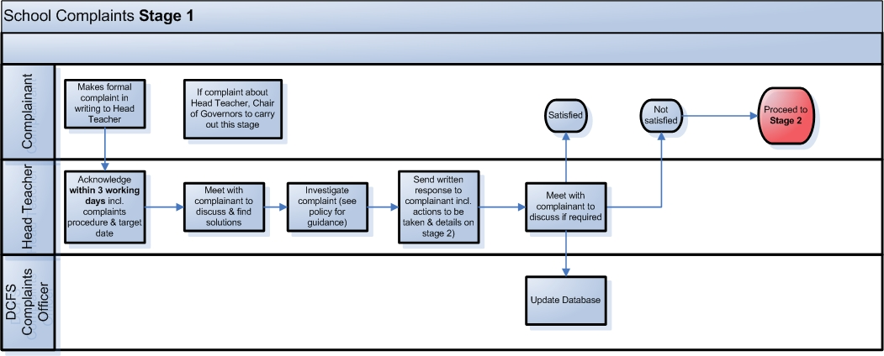

School Complaints Stage 2
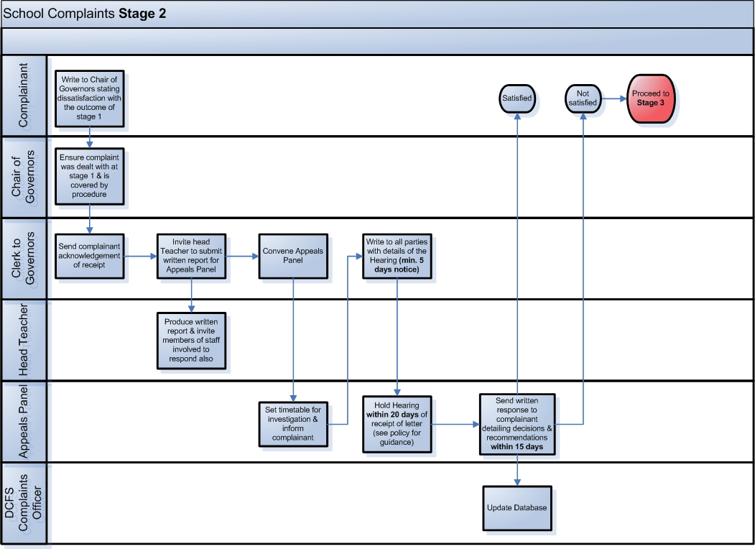

School Complaints Stage 3

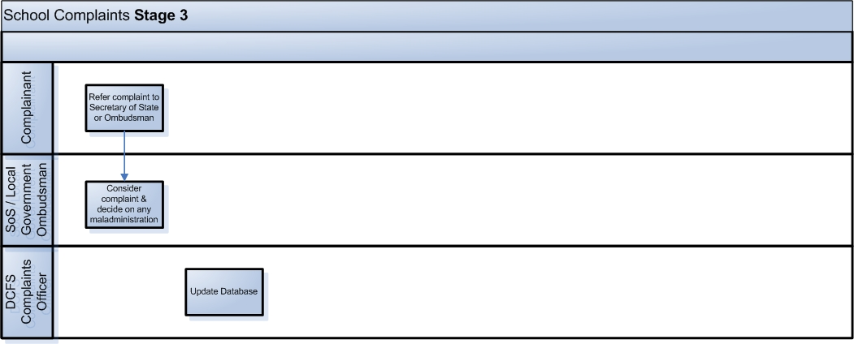

Unreasonable or unreasonably persistent complaints

