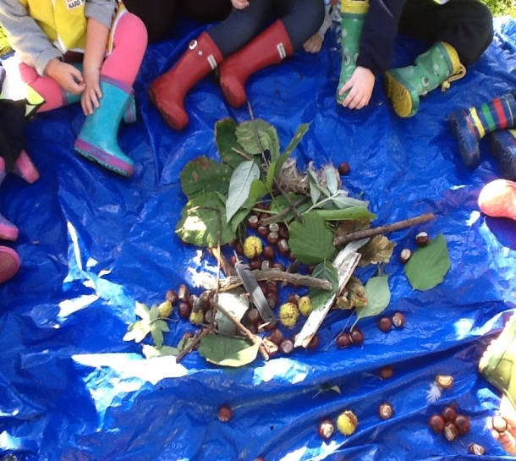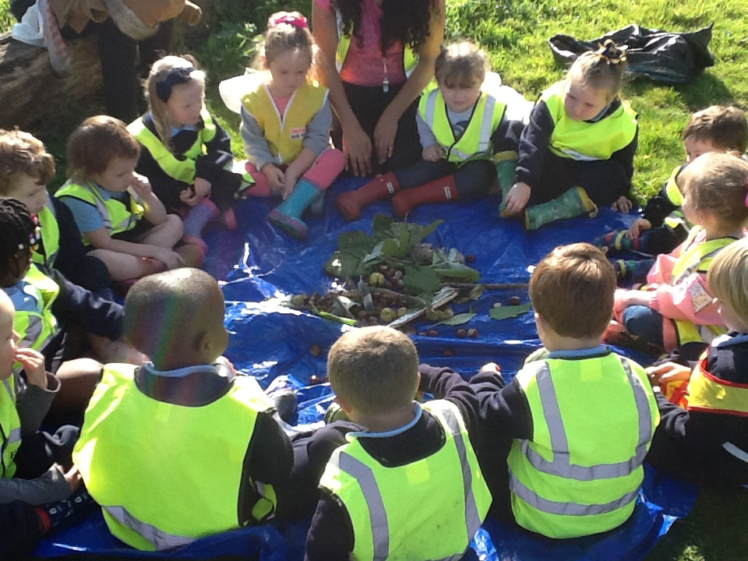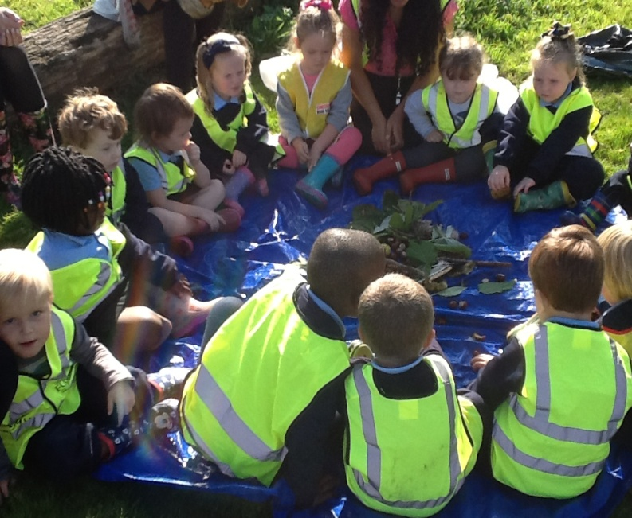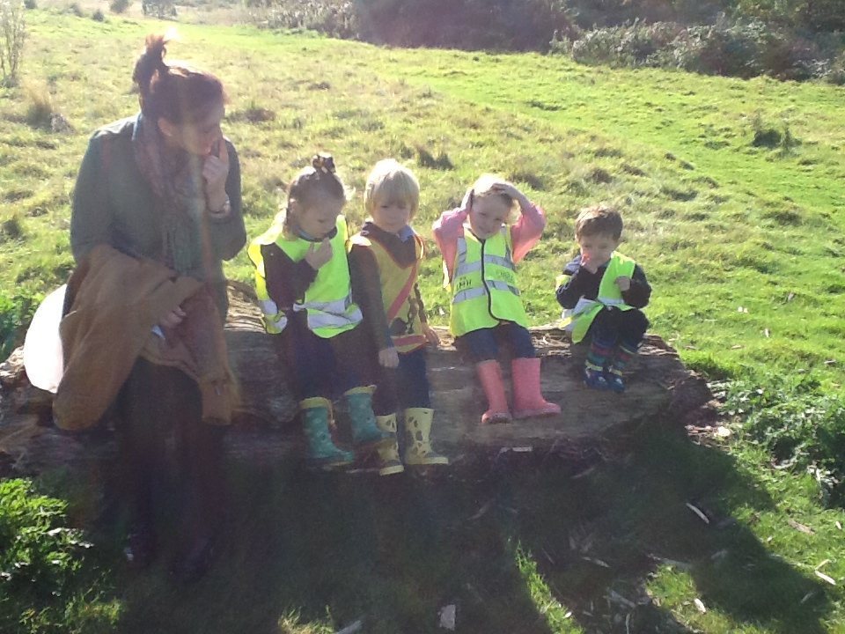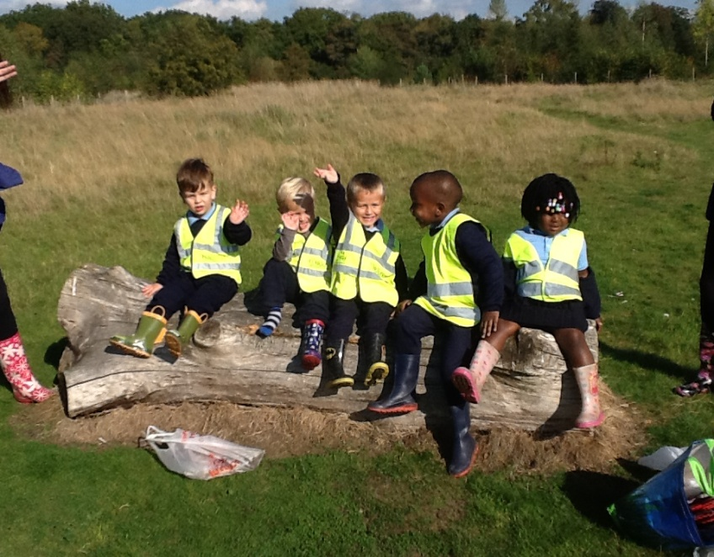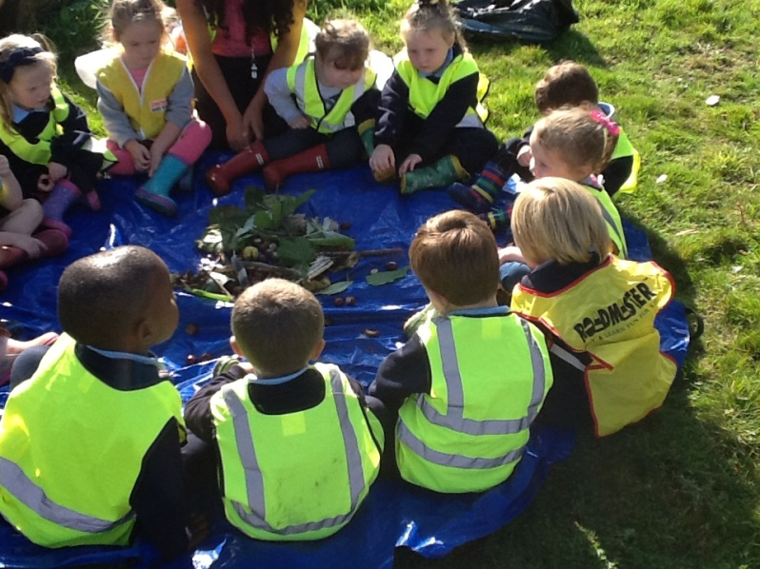

**After collecting a range of natural resources from our environment, we found a circle of logs, so we decided to get in our groups and have a rest. The logs were rough, hard and bumpy! We looked around us and we could see lots of green grass, trees, red berries and much more!**

**We sat in a circle to examine some of the resources we had found.**

**There were smooth, round conkers, prickly cases, red, soft berries and hard, bumpy twigs and so on.**

**We didn’t taste anything because it was dangerous!**