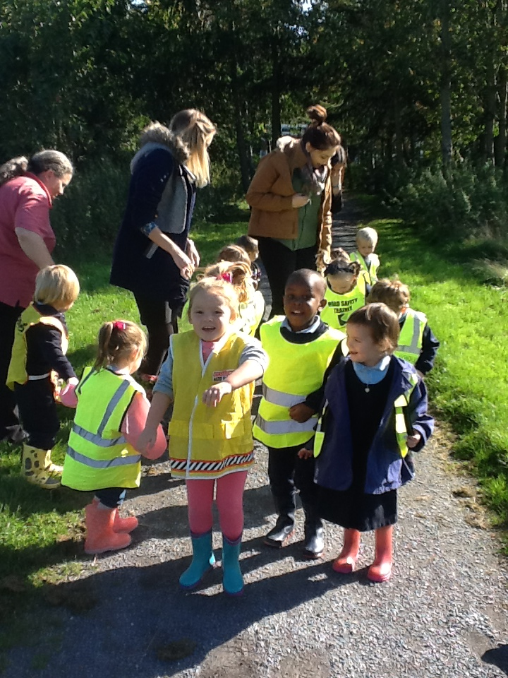

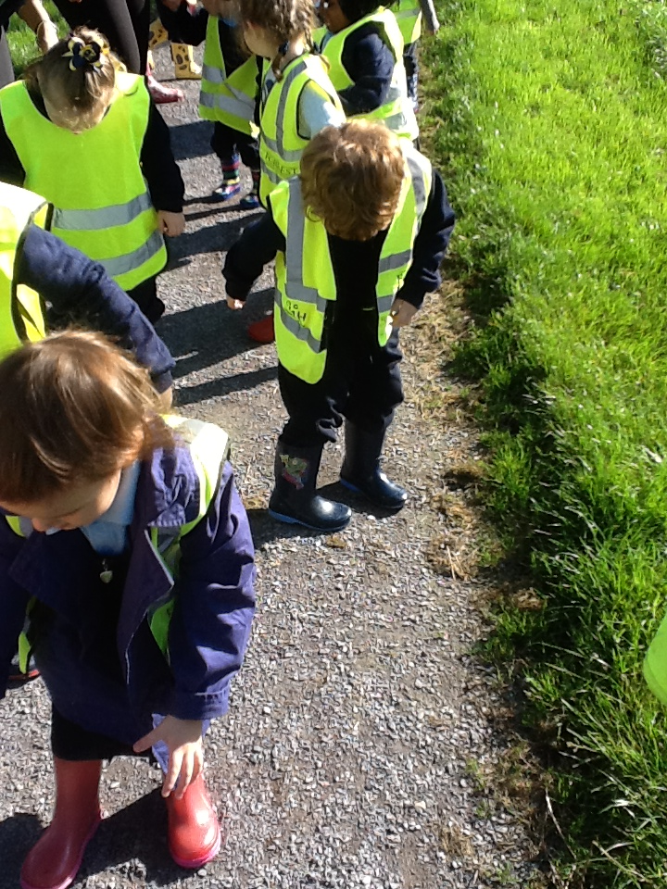

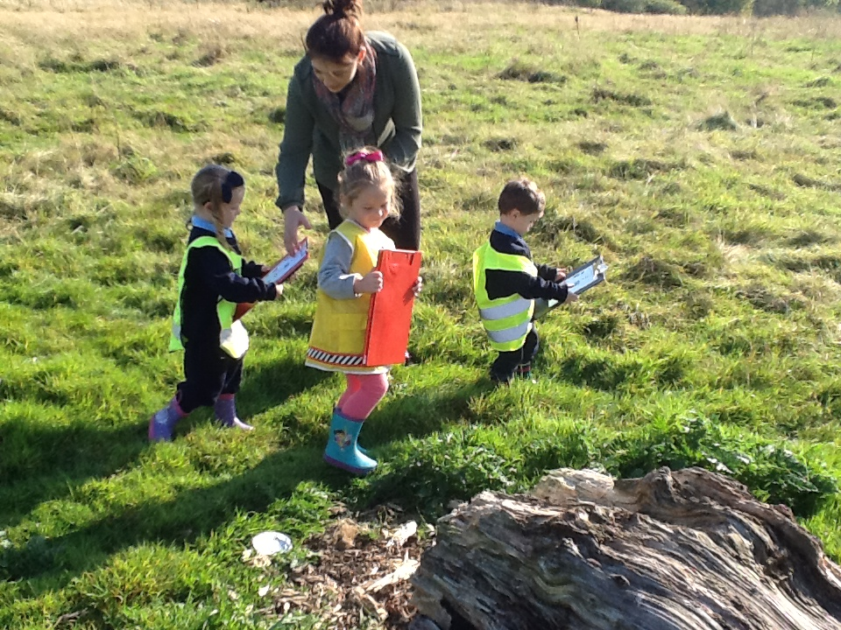

**We are stomping and scraping against the hard, grey, stony floor. We can hear stomping, scraping, scrunching and crushing sounds! We can feel a hard, lumpy and bumpy floor!**

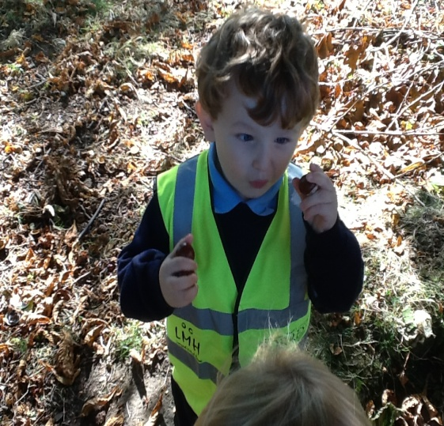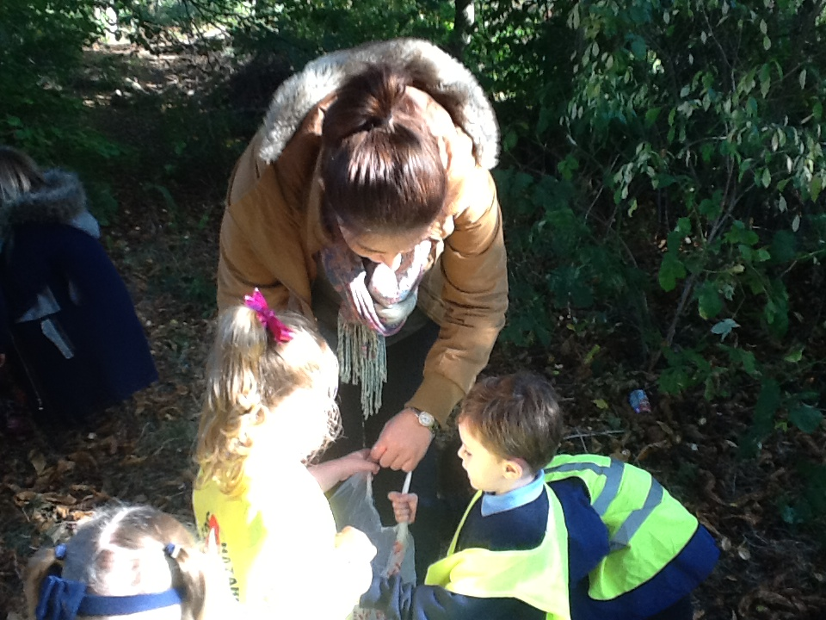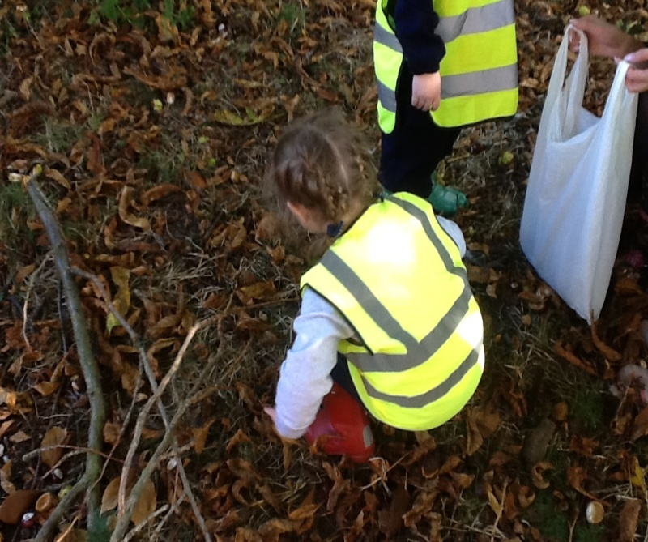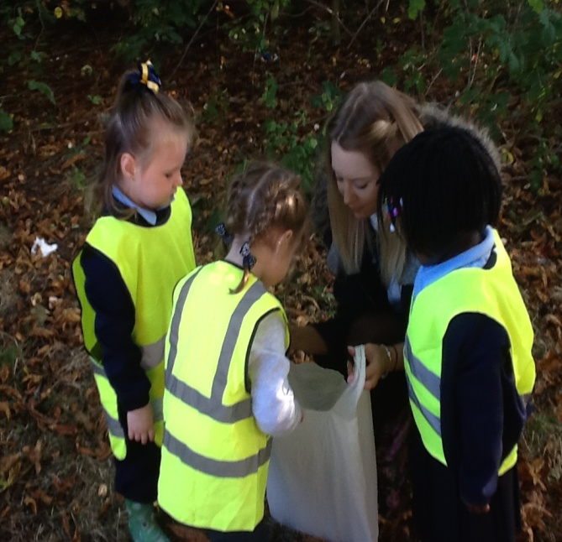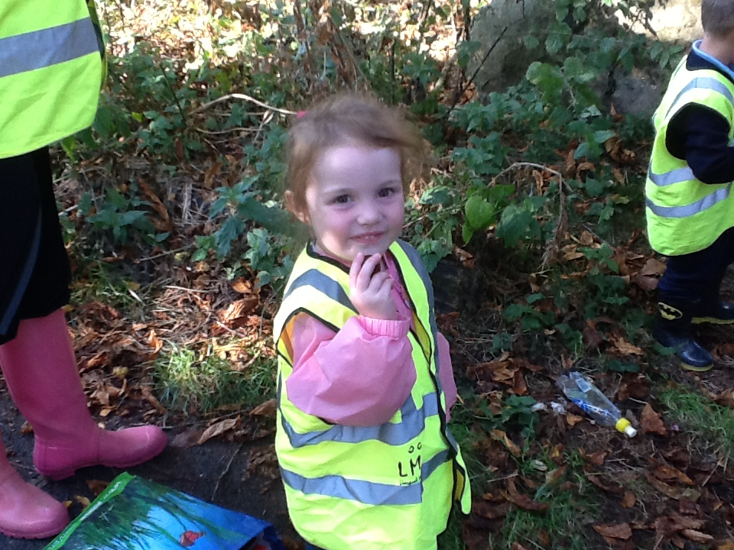 bcnnnznmxbcnzcb

**We walked through long, wavy grass and squelching mud. We then looked for lots of things that we found interesting, to collect for further investigation.**