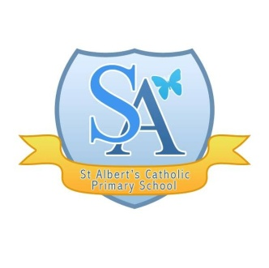
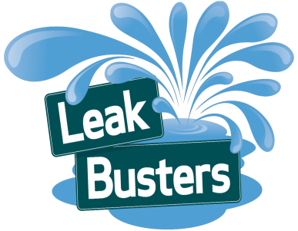
If you are interested in entering see Miss Stephens during lunch time or after school for more details.
You will be able to use the school equipment to create your advert during lunch times, with support.
Would you like to create a radio advert that could be chosen and used on our local radio?
We have been offered the opportunity to write and create a radio advert for United Utilities in conjunction with UTV. The winning advert will be professionally produced and used on radio stations across the North West.

The Brief

Winter Wise - Deadline 19th December 2014
Create a radio advert that explains what winter wise is and how you can prevent problems in your home during the cold season.

Are you ready for winter? When the temperature
begins to fall, it's time to wrap your home up nice
and snug and we need your help to inform people
how to protect their homes in cold weather. It's easy
to get prepared for the cold snap and there are a
few tips and tricks you can follow to avoid frozen
pipes and flooded homes this winter.

We want YOU to create an audio commercial encouraging others to be aware of the hazards the winter can bring. Your commercial should last no more than 60 seconds and should also include the United Utilities website address -www.unitedutilities.com

If your commercial is chosen as the winner
we will arrange for the group to visit a local
radio station to record their commercial
professionally and it will also get played
on local radio for thousands of people to hear.
Good luck!

The Brief

Leak Line - 19th December 2014
Create a radio advert to inform others what to do when a leak occurs and how to prevent them.

United Utilities are doing all they can to
prevent leaks, but sometimes due to
weather conditions and general maintenance
they can still occur. But with your help
United Utilities can tackle the problem as soon
as they are aware. So if you spot a leak in the
road or footpath, please report it.

We want YOU to create an audio commercial encouraging others to check for leaks and help prevent them from occurring. Your commercial should last no more than 60 seconds and should also include the United Utilities website address -www.unitedutilities.com

If your commercial is chosen as the winner
we will arrange for the group to visit a local
radio station to record their commercial
professionally and it will also get played on
local radio for thousands of people to hear.
Good luck!

