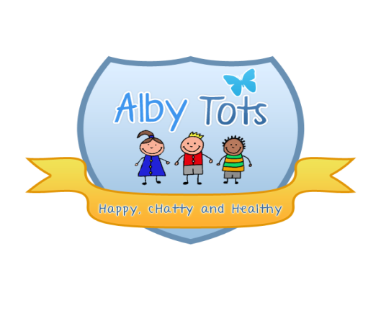
St Albert’s Catholic Primary School: EYFS
Separated family Policy

When parents separate it is a difficult situation for all concerned. The EYFS understands that emotions run high and this policy lays out how the nursery will support the child and their family within the nursery. We feel this policy will support all parties in this difficult time including our team.
Parental responsibility
While the law does not define in detail what parental responsibility is, the following list sets out the key roles:
Providing a home for the child
Having contact with and living with the child
Protecting and maintaining the child
Disciplining the child
Choosing and providing for the child's education
Determining the religion of the child
Agreeing to the child's medical treatment
Naming the child and agreeing to any change of the child's name
Accompanying the child outside the UK and agreeing to the child's emigration, should the issue arise
Being responsible for the child's property
Appointing a guardian for the child, if necessary
Allowing confidential information about the child to be disclosed.

If the parents of a child are married to each other at the time of the birth, or if they have jointly adopted a child, then they both have parental responsibility. Parents do not lose parental responsibility if they divorce, and this applies to both the resident and the non-resident parent.
This is not automatically the case for unmarried parents. According to current law, a mother always has parental responsibility for her child. A father, however, has this responsibility only if he is married to the mother when the child is born or has acquired legal responsibility for his child through one of these three routes:
By jointly registering the birth of the child with the mother (From 1 December 2003)
By a parental responsibility agreement with the mother
By a parental responsibility order, made by a court.

Registration
During the registration process it is important for the nursery to know all details about both parents. This includes details about who does or does not have parental responsibility as this will avoid difficult situations that may arise at a later date.
The nursery requests that all details are logged on the child registration form. If a parent does not have parental responsibility, or has a court order in place to prevent this, the nursery needs a copy of this documentation for the child’s records.
If a child is registered by one parent of a separated family, the nursery requests that all details relating to the child and other parent are disclosed wherever possible, e.g. court orders, injunctions. This will allow the nursery to have all the appropriate information in order to support the child fully.
The nursery will:
Ensure the child’s welfare is paramount in all operations relating to their time within the nursery
Comply with any details of a Court Order where they are applicable to the nursery’s situation, provided the nursery has seen a copy/has a copy attached to the child’s file
Provide information on the child’s progress within the nursery to both parents
Ensure that all matters known by the staff pertaining to the family and the parent’s separation shall remain confidential
Ensure that no member of staff takes sides within the separation and treats both parents equally and with due respect.

The nursery cannot restrict access to any parent with parental responsibility unless a formal Court Order is in place. We respectfully ask that parents do not put us in this position.
We ask parents to:
Provide us with all information relating to parental responsibilities, Court Orders and injunctions
Update information that changes any of the above as soon as practicably possible
Work with us to ensure continuity of care and support for your child
Not involve nursery staff in any family disputes, unless this directly impacts on the care we provide for the child
Talk to the manager/key person away from the child when this relates to family separation in order to avoid the child becoming upset. This can be arranged as a more formal meeting or as an informal chat
Not ask nursery to take sides in any dispute. We will only take the side of your child and this will require us.

Signed: R.Henderson
Date: September 2014

