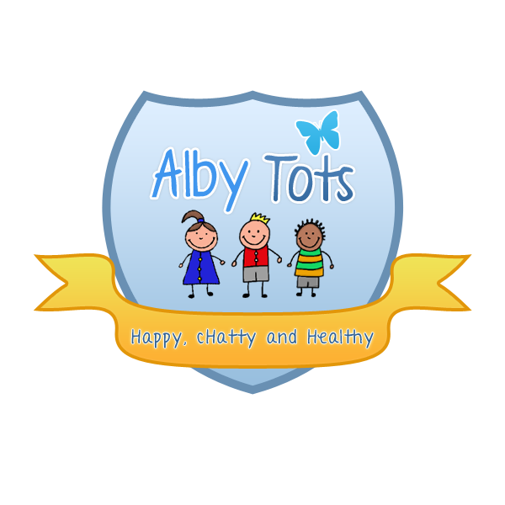
St Albert’s Catholic Primary School: Alby tots Nursery
Inclusion and Equality Policy

EYFS: 1.7, 3.20, 3.25, 3.67

Statement of intent
At Alby Tots we take great care to treat each individual as a person in their own right, with equal rights and responsibilities to any other individual, whether they are an adult or a child. We are committed to providing equality of opportunity and anti-discriminatory practice for all children and families according to their individual needs. Discrimination on the grounds of gender, age, race, religion or belief, marriage or civil partnership, disability, sexual orientation, gender reassignment, pregnancy or maternity, ethnic or national origin, or political belief has no place within our nursery.

A commitment to implementing our inclusion and equality policy will form part of each employee’s job description. Should anyone believe that this policy is not being upheld, it is their duty to report the matter to the attention of the Lorraine McEvoy at the earliest opportunity. Appropriate steps will then be taken to investigate the matter and if such concerns are well-founded, disciplinary action will be invoked under the nursery’s disciplinary policy.

The legal framework for this policy is based on:
- Equality Act 2010
- Children Act 2004
- Care Standards Act 2002
- Childcare Act 2006
- Special Educational Needs and Disability Act 2001
- Children and Families Act 2014.

The nursery and staff are committed to:
- Recruiting, selecting, training and promoting individuals on the basis of occupational skills requirements. In this respect, the nursery will ensure that no job applicant or employee will receive less favourable treatment because of age, sex, gender reassignment, disability, marriage or civil partnership, race, religion or belief, sexual orientation, pregnancy or maternity which cannot be justified as being necessary for the safe and effective performance of their work or training
- Providing a childcare place, wherever possible, for children who may have learning difficulties and/or disabilities or are deemed disadvantaged according to their individual circumstances, and the nursery’s ability to provide the necessary standard of care
- Making reasonable adjustments for children with special educational needs and disabilities
- Striving to promote equal access to services and projects by taking practical steps (wherever possible and reasonable), such as ensuring access to people with additional needs and by producing materials in relevant languages and media for all children and their families
- Providing a secure environment in which all our children can flourish and all contributions are valued
- Including and valuing the contribution of all families to our understanding of equality, inclusion and diversity
- Providing positive non-stereotypical information
- Continually improving our knowledge and understanding of issues of equality, inclusion and diversity
- Regularly reviewing, monitoring and evaluating the effectiveness of inclusive practices to ensure they promote and value diversity and difference and that the policy is effective and practices are non-discriminatory
- Making inclusion a thread, which runs through the entirety of the nursery, for example, by encouraging positive role models through the use of toys, imaginary play and activities, promoting non-stereotypical images and language and challenging all discriminatory behaviour (see dealing with discriminatory behaviour policy).

Admissions/service provision
The nursery is accessible to all children and families who qualify for the 2 year old offer within the local area.

The nursery will strive to ensure that all services and projects are accessible and relevant to all groups and individuals in the community within targeted age groups.

Recruitment
All members of the selection group will be committed to the inclusive practice set out in this policy and will have received appropriate training in this regard.

Application forms will be sent out along with a copy of the equal opportunities monitoring form. Application forms will not include questions that potentially discriminate on the grounds specified in the statement of intent.

At interview, no questions will be posed which potentially discriminate on the grounds specified in the statement of intent. All candidates will be asked the same questions and members of the selection group will not introduce nor use any personal knowledge of candidates acquired outside the selection process. Candidates will be given the opportunity to receive feedback on the reasons why they were not successful.

Staff
It is the policy of Alby Tots not to discriminate in the treatment of individuals. All staff are expected to co-operate with the implementation, monitoring and improvement of this and other policies. All staff are expected to challenge language, actions, behaviours and attitudes which are oppressive or discriminatory on the grounds specified in this policy and recognise and celebrate other cultures and traditions. All staff are expected to participate in equality and inclusion training.

Staff will follow the whistleblowing policy where applicable to report any discriminatory behaviours observed.

Training
The nursery recognises the importance of training as a key factor in the implementation of an effective inclusion and equality policy. All new staff receive induction training including specific reference to the inclusion and equality policy. The nursery will strive towards the provision of inclusion, equality and diversity training for all staff on an annual basis.

Early learning framework
Early learning opportunities offered in the nursery encourage children to develop positive attitudes to people who are different from them. It encourages children to empathise with others and to begin to develop the skills of critical thinking.

We do this by:
- Making children feel valued and good about themselves
- Ensuring that all children have equal access to early learning and play opportunities
- Reflecting the widest possible range of communities in the choice of resources
- Avoiding stereotypical or derogatory images in the selection of materials
- Acknowledging and celebrating a wide range of religions, beliefs and festivals
- Creating an environment of mutual respect and empathy
- Helping children to understand that discriminatory behaviour and remarks are unacceptable
- Ensuring that all early learning opportunities offered are inclusive of children with learning difficulties and/or disabilities and children from disadvantaged backgrounds
- Ensuring that children whose first language is not English have full access to early learning opportunities and are supported in their learning
- Working in partnership with all families to ensure they understand the policy and challenge any discriminatory comments made
- Ensuring the medical, cultural and dietary needs of children are met
- Helping children to learn about a range of food and cultural approaches to meal times and to respect the differences among them.

Information and meetings

Information about the nursery, its activities and their children’s development will be given in a variety of ways according to individual needs (written, verbal and translated), to ensure that all parents can access the information they need.

Wherever possible, meetings will be arranged to give all families options to attend and contribute their ideas about the running of the nursery.

This policy was adopted on | Signed on behalf of the nursery | Date for review
SEPTEMBER 2014 | RHIANON HENDERSON | SEPTEMBER 2015

