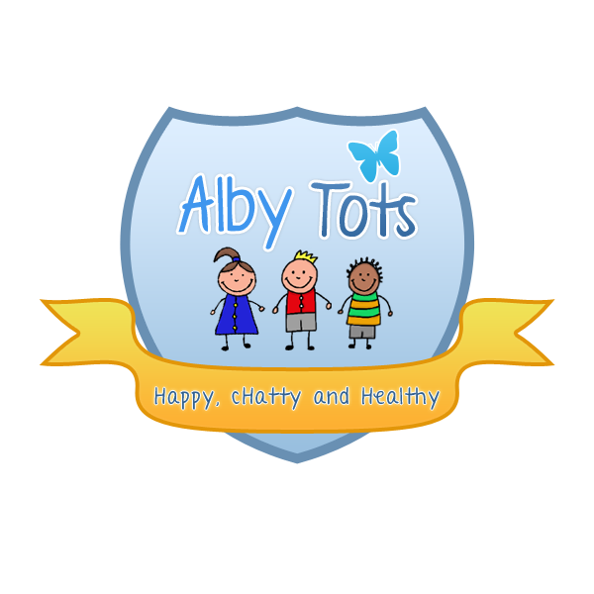
St Albert’s Catholic Primary School: EYFS
Food and nutrition

Hygiene in the kitchen
Before adults prepare or handle food they must wash their hands thoroughly and protective clothing must be worn i.e. apron and hair net.
All food should be piping hot and above 63 degrees.
Staff must use the appropriate chopping boards when handling meat, fish, fruit and vegetables. All food should be kept covered and refrigerated where appropriate.
All waste food should be disposed of in the appropriate bins and hands washed after use.
Dishcloths and tea towels should be washed daily.
Nutrition and mealtimes EYFS 3.45 - 3.47
Mealtimes should be a happy, social occasion for children and staff alike. Positive interactions should be shared at these times and enjoyed. The Dolphin is committed to offering children healthy, nutritious and balanced meals and snacks which meet individual needs and requirements.
We will ensure that:
A balanced and healthy midday meal, tea and daily snacks are provided for children attending a full day at the nursery
Menus are planned in advance, rotated regularly and reflect cultural diversity and variation. These are displayed for children and parents to view
We provide nutritious food at all snack and meal times, avoiding large quantities of fat, sugar and salt and artificial additives, preservatives and colourings
Parents and children are involved in menu planning
Fresh drinking water is constantly available and accessible. It is frequently offered to children and babies.
Individual dietary requirements are respected. We gather information from parents regarding their children’s dietary needs including any special dietary requirements, preferences and food allergies that a child has and any special health requirements before a child is admitted to the nursery. Where appropriate we will carry out a risk assessment in the case of allergies and work alongside parents to put into place an individual dietary plan for their child
Staff show sensitivity in providing for children’s diets and allergies. They do not use a child’s diet or allergy as a label for the child, or make a child feel singled out because of her/his diet or allergy
Meal and snack times are organised so that they are social occasions in which children and staff participate in small groups. During meals and snack times children are encouraged to use their manners and say 'please' and 'thank you' and conversation is encouraged
Staff use meal and snack times to help children to develop independence through making choices, serving food and drink, and feeding themselves.
We provide foods from the diet of each of the children’s cultural backgrounds, providing children with familiar foods and introducing them to new ones. Cultural differences in eating habits are respected
Children are given time to eat at their own pace and not rushed
Quantities offered take account of the ages of the children being catered for
We promote positive attitudes to healthy eating through play opportunities and discussions
The nursery provides parents with daily records of feeding routines for all children under 3 or until they move into Pre School.
No child is ever left alone when eating/drinking to minimise the risk of choking

All staff that prepare and handle food are competent to do so and receive training in food hygiene.
Food supplied by parents
If parents wish to supply food for their own child’s consumption on the premises, they must be aware of food hygiene when preparing packed lunches or snacks. This includes checking dates for consumption of both dried and perishable foods As consumption of all food on the nursery premises, inclusive of that provided by parents, is ultimately our responsibility, the following policy must be observed at all times.

Any perishable foods inclusive of dairy and meat products must be identified by parents and labelled with their child's name.
Any food not consumed by a child will be returned to parents that same day.
Food brought to the nursery by a parent to meet a child's specific dietary requirements can only be stored on a weekly basis and must be collected at the end of the week.
It is the parents responsibility to ensure that any food requiring re-heating has been stored suitability since it was originally cooked. Unfortunately we cannot reheat any meal that includes rice due to the high risk involved in its storage after initial cooking.
Any meals to be reheated with be warmed to a minimum of 74 degrees C and allowed to cool before the child eats it.

Signed: R.Henderson
Date: September 2014

