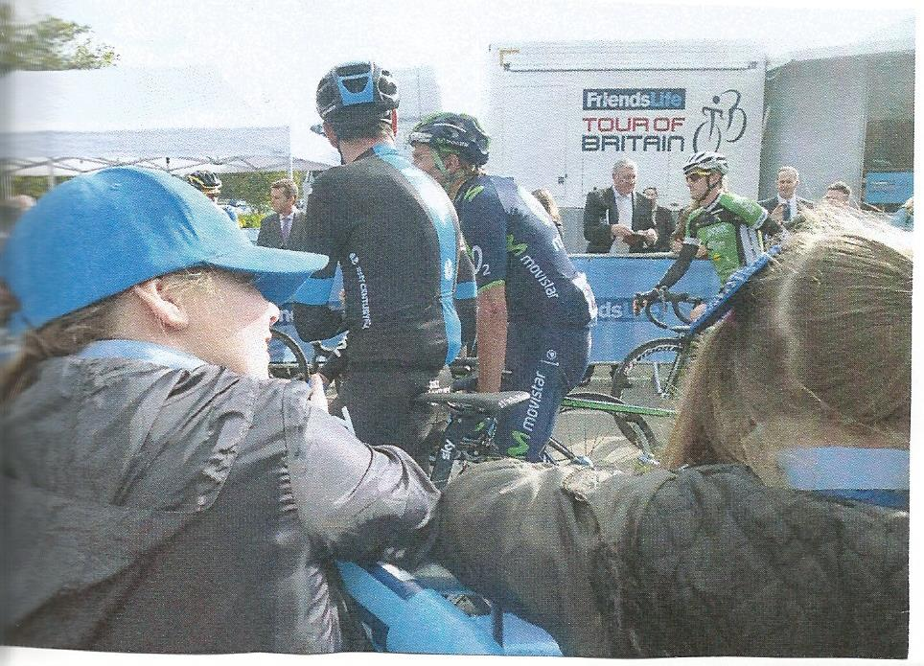 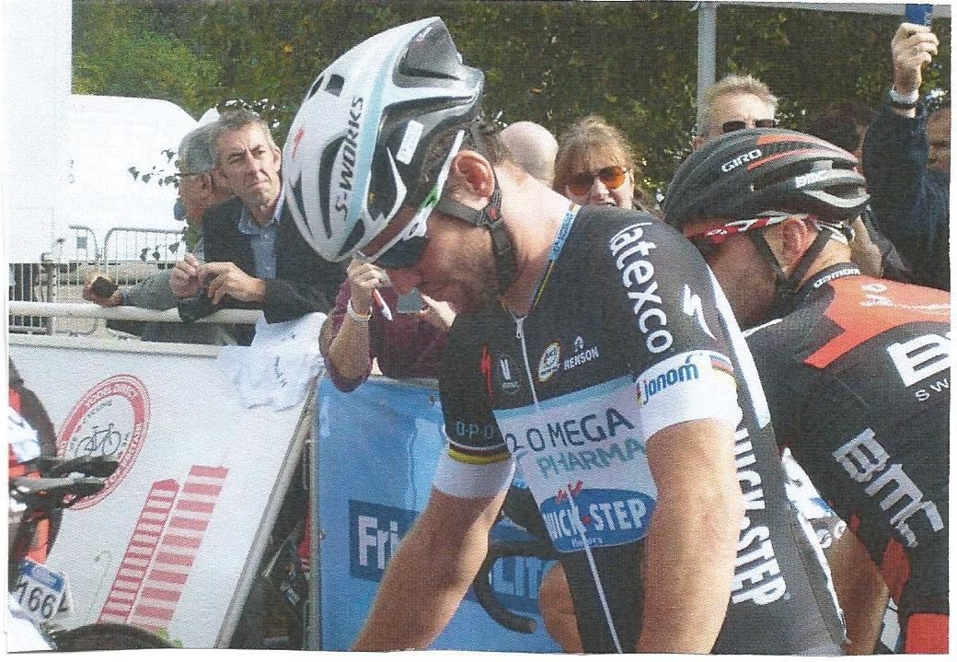

Year 6 went to see ‘The Tour of Britain’ on Monday 8th September at Knowsley Safari Park. The children were all very excited to see some of the most well known professional cyclists from around the world such as Bradley Wiggins and Mark Cavendish. The children took photographs of the event with our school ipads and were able to take a close up of Mark Cavendish! Some of our children were even interviewed by ITV! You can watch this by clicking on the link below:

<http://www.itv.com/news/granada/update/2014-09-08/tour-of-britain-cyclists-cheered-through-region/>

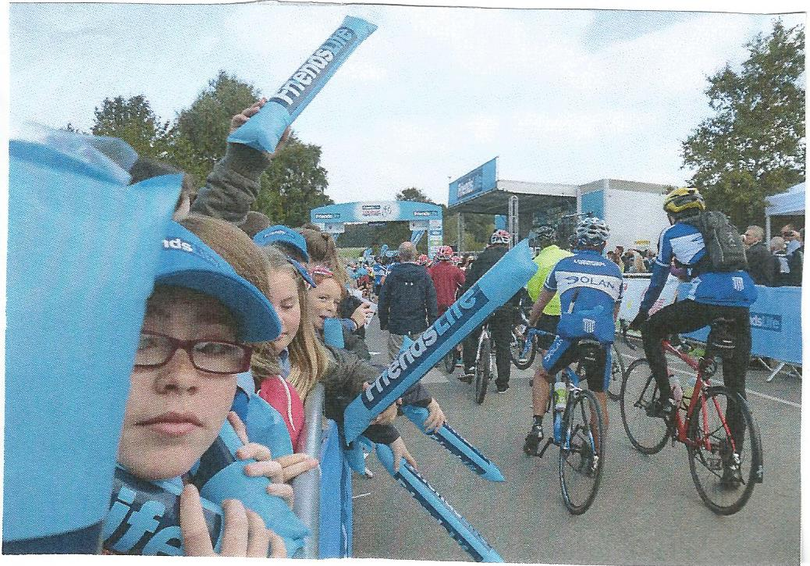

Inspired by this visit, we will be trying to organise cycling and BMX sessions for the children at the recently opened Velodrome in Knowsley! Watch this space!