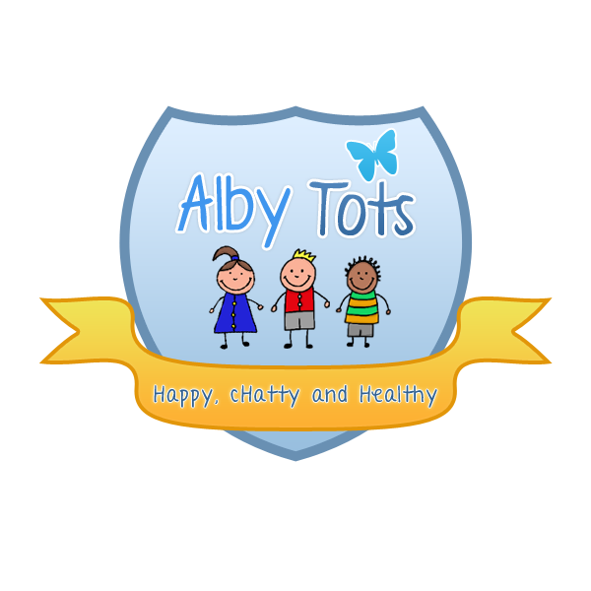
Alby Tots Smoking, Drugs and Alcohol Policy

Policy Statement for Smoking Drugs and Alcohol
References/Legislation that informs this policy
UN Convention on the Rights of the Child – 1989 (Ratified 1999)
The Children Act 1989
The Children Act 2004 (Every Child matters)
The Medicines Act 1968
The Misuse of Drugs Act 1971
Control of Substances Hazardous to Health Regulations (COSHH)
Smoke-Free (Premises and Enforcement) Regulations
Smoke–Free (Signs) Regulations

1. Introduction
1.1 It is the intention of Alby Tots to promote and protect the health and well being of its children, employees and other visitors to the nursery. It is recognised that smoking is bad for health and unpleasant to many users of buildings and services. We believe that those working with children are in a unique position to act as positive role models and have a responsibility to send out consistent messages about hazards of smoking. This also applies to alcohol and drug abuse.
1.2 This policy applies to all employees, parents, trainees, students, contractors and other users and visitors to the nursery.
1.3 Smoking is strictly prohibited on or near the nursery premises. Should a member of staff wish to have a cigarette on their break they must not light up in the nursery, buildings, or grounds and this includes doorways, entrances, walkways, playgrounds or car park. Staff are not permitted to consume alcohol during their contracted hours of work or to care for the children if they have consumed alcohol prior to commencing work. Consumption of alcohol is not permitted in the nursery, buildings or grounds and this includes doorways, entrances, walkways, playgrounds or the car park.
1.4 The same applies to all drugs other than those prescribed by a doctor and considered appropriate for intake while working with children.
1.5 Such medication must not be kept in a handbag. It must be taken from the bag and put into a medicine cabinet locked away in a secure drawer that children have no access too. It is the responsibility of the person to whom the medication belongs, to ensure the medication is stored correctly, well away from all children in the office. Staff needing to take prescribed medication during their working hours, must do in the office/staff room.
1.6 Misuse of prescription drugs and over the counter drugs, including legal highs is also prohibited at any time.

2. Parent/Carer co-operation

2.1 Parents/carers are not allowed to smoke, take drugs or consume alcohol while on the nursery premises. This includes trips with the nursery off the premises and in the presence of other children at nursery or parents.
2.2 Parents/carers are forbidden to bring alcohol or drugs into the nursery grounds.
Parents/carers being abusive to children, staff members or other parents while on the premises will be asked to leave. Police may be called in this instance. In the event we will ask that someone comes to take responsibility of the child. I.e. grandparent, auntie. If a carer has been abusive we will inform the parent and wait for them to collect the child. The perpetrator will no longer be allowed into or near the nursery premises.
2.3 The parent/carer that has been abusive may be told to refrain from bringing their child to nursery while an inquiry takes place. However if the incident is severe enough to have police involved the parent/carer may be told that their child’s place had been permanently revoked. Under these circumstances no monies outstanding for the week will be reimbursed to the parent.
2.4 Parents/carers are asked not to take calls on their mobile phones while dropping/collecting their child from nursery. We understand that at time this may not be possible, however, we ask parents/carers to refrain from using aggressive/abusive language while on their mobile phone, inside, or on nursery premises.
2.5 Any supply of drugs via parent/carer while on/in nursery premises will result in a loss of child place and result in a phone call to local authorities to report the incident.
2.6 Cigarettes/tobacco and lighters, alcohol, drugs/medicine are forbidden to be left in a child’s bag/belongings. These will be discarded by a staff member and the parent/carer will be informed immediately. This may result in loss of child’s place.
2.7 All our staff has the right to work without concern of intimidation or assault. We will not accept this behaviour on the premises and will ask anyone who does not respect this to leave. We will take further action if this is not adhered to.

We have a nursery collection policy for a parent/carer under the influence of alcohol or drugs. The following guidelines will apply:

We will manage the incident tactfully to ensure that the professional relationship with the family is maintained.
• If a senior staff member has any concerns regarding the child’s welfare, we would endeavour to speak to the parent/carer about their child’s needs. Procedure will be followed in guidance with the nursery Safeguarding Policy.
• We will ensure that there is two staff present when speaking to a parent so that staff should not jeopardise their own safety or others in these situations.
• In the event that the parent/carer arrives at the nursery under the influence of alcohol or drugs we will ask that someone comes with the parent/carer to take responsibility of the child.
• Should this not happen, although we have no legal right to withhold a child from a parent/carer, we reserve the right to contact any relevant authorities that we deem appropriate i.e. the police, partner etc. Any member of staff feeling under threat should contact the police in the first instance.
• Full written report will be made of the incident.
• A child’s safety is our main concern and as such this will determine the course of action taken.
• When events are booked, individuals to be made aware of the Smoking, Drugs and Alcohol Policy.

3. Parents
3.1 Parents to be informed of this Smoking, Drugs and Alcohol Policy and any changes thereafter through newsletters and other forms of communication.
3.2 Parents/carers will be offered the same confidential support and given details for support services as employees, should it be required.

4. Signage
4.1 Clearly worded no smoking signs will be sited at the gates, entrance(s) and in the prominent positions throughout the nursery premises. This complies with current legislation.

Review
This policy will be monitored annually by management in consultation with staff and a report made to parents asking for their views and considerations to be taken into account.
September 2014
R. Henderson

