St Albert’s
British Values Statement 2015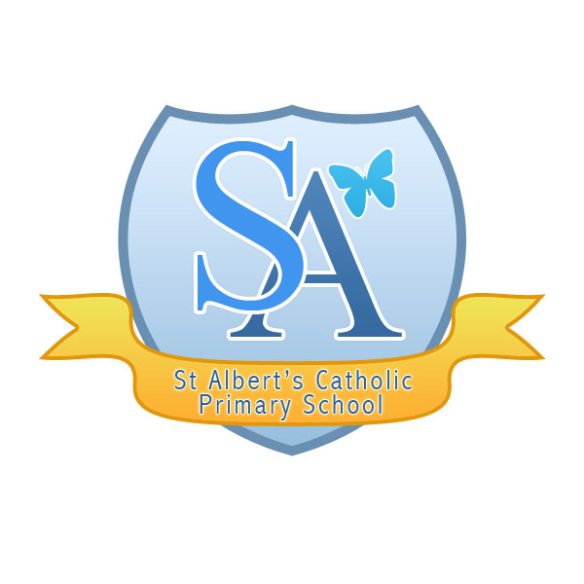
Background
The DfE have recently reinforced the need “to create and enforce a clear and rigorous expectation on all schools to promote the fundamental British values of democracy, the rule of law, individual liberty and mutual respect and tolerance of those with different faiths and beliefs.”

The Government set out its definition of British values in the 2011 Prevent Strategy, and these values have been reiterated this year (2014). At St Albert’s these values are reinforced regularly and in the following ways. We keep an up to date audit of all such teaching and learning opportunities.

Democracy
St Albert’s are working towards becoming a UNICEF Rights Respecting school. Each year the children will decide upon their class charter and the rights associated with these. All the children will contribute to the drawing up of the charter.
Children have many opportunities for their voices to be heard. We have a school council which meets regularly to discuss issues raised in class council meetings. The council has its own budget and is able to genuinely effect change within the school. Two of the three council members for each year group are voted in by their class.
Each term the children in years 2-6 are able to nominate and vote for children to achieve an “excellence certificate”.
Children have an annual questionnaire with which they are able to put forward their views about the school.

The Rule of Law
The importance of Laws, whether they be those that govern the class, the school, or the country, are consistently reinforced throughout regular school days, as well as when dealing with behaviour and through school assemblies. Pupils are taught the value and reasons behind laws, that they govern and protect us, the responsibilities that this involves and the consequences when laws are broken. Visits from authorities such as the Police and Fire Service help reinforce this message.

We are a Restorative Practice school and this contributes significantly to the children’s understanding of the Rule of Law.

Individual Liberty
Within school, pupils are actively encouraged to make choices, knowing that they are in a safe and supportive environment. As a school we educate and provide boundaries for young pupils to make choices safely, through provision of a safe environment and empowering education. Pupils are encouraged to know, understand and exercise their rights and personal freedoms and advised how to exercise these safely, for example through our E-Safety and PSHE lessons. Whether it be through choice of learning challenge, of how they record, of participation in our numerous extra-curricular clubs and opportunities, pupils are given the freedom to make choices.

Mutual Respect
As a Rights Respecting School and a Catholic School, mutual respect is at the heart of our values. Children learn that their behaviours have an effect on their own rights and those of others. All members of the school community treat each other with respect. Part of our school ethos and behaviour policy has revolved around Core Values such as ‘Respect’, and pupils have been part of discussions and assemblies related to what this means and how it is shown.

Tolerance of those of Different Faiths and Belief

This is achieved through enhancing pupils understanding of their place in a culturally diverse society and by giving them opportunities to experience such diversity. St Albert’s is increasingly becoming a more diverse school with a growing number of children with from different ethnic backgrounds and this is enabling us to promote tolerance and respect first hand. We are situated in an area which is not greatly culturally diverse, however and therefore we place a great emphasis on promoting diversity with the children. Assemblies are regularly planned to address this issue either directly or through the inclusion of stories and celebrations from a variety of faiths and cultures. Assemblies and discussions involving prejudices and prejudice-based bullying have been followed and supported by learning in RE and PSHE. Our RE and PSHE teaching reinforce this. Members of different faiths or religions are encouraged to share their knowledge to enhance learning within classes and the school. Children visit places of worship that are important to different faiths.
At St Albert’s we will actively challenge pupils, staff or parents expressing opinions contrary to fundamental British Values, including ‘extremist’ views.

PREVENT Strategy
Two members of the SLT, including the headteacher, recently undertook training on ‘Prevent’. This is due to cascaded to all relevant staff in the Autumn term 2015.

Some identified activities (these will be added to throughout the year as we respond to different events

Mutual Respect
PSHE
RE curriculum
Catholic ethos
Competitive sports links
Play Leaders
Teachers’ code of conduct
Adults model respectful behaviour
Restorative practice
Check in circles
Collective worship
Behaviour policy and sanctions shared with children and parents
Coffee mornings
Other faiths weeks
Assemblies
Listening skills, team work skills focus weeks.
Be-frienders
Inside Out project

Rule of Law
Develop Link with local MP
Elections Focus
Behaviour Policy
Parent Questionnaires
Link with Police community
Police who visit school regularly
Crucial Crew in Y6
Fire Safety
E-Safety CEOP in ALL Classes
Bikeability
PSCHE Curriculum
Democracy
Student Council elections
Children apply to be prefects
Y6 visit to London
Mock elections for government
Children created their own political parties and manifestos.
Pupil voice
Assertive mentoring meetings
Restorative practice
Pupil surveys
Visits from local MP’s
Children create own class riles

.
BRITISH VALUES AT ST ALBERT’S
Tolerance of Culture,
Faith and Others
RE curriculum
Other faiths weeks
Harvest celebration
Assemblies
Exploration of other cultures during topic work
Excellent links with parish church
Assemblies
Anti racism policy
Black History week
Studying literature e.g. Boy in the Striped Pyjamas, War Horse, Skellig, Anne Frank and Savage.
African Week, Spanish week. Olympics. Paralympics. Equal opportunities focus week.
Anthony Walkeer Foundation Workshop

Personal Responsibility and Liberty
Independent learners
School uniform
P.E. kit
Reading diaries
Homework
Walking to swimming
PSHE
Assertive mentoring
Children involved in target setting
Restorative Practice
Play Leaders
Charity Work – ie Refugee, McMillan
War Memorial Visits
Smilie Rewards
Prefects

