Child facing the camera
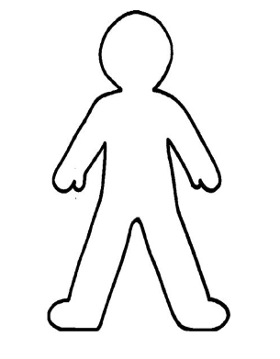

Child’s right side Child’s left side

