St Albert's Catholic Primary School
Steers Croft Stockbridge Village Liverpool L28 8AJ
Te1 0151 477 8560 Fax 0151 477 8561 emai1 stalbert@knowsley.gov.uk
Headteacher Mrs L McEvoy
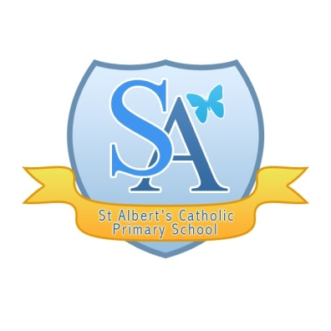
“Walking together with Jesus to Love, Learn and Serve”

22nd May 2020

Dear Parents

I hope that you are all keeping well, surviving the lock down and staying safe and alert!
As you will be aware, we have not ‘closed’ school but rather we have been offering emergency child care to key worker children whilst supporting our other families and providing remote learning. After the Whit holidays we will be re-opening the school again to an increased number of children and we have been working hard with our potential plans and working out how we can achieve this and keep our children, staff and families safe. We have done this with governors, local schools and we have considered all the necessary guidance.

It is important to remember that the school can only potentially open if the five tests that the Government have stipulated are met by 8th June. These five tests are:
- Protect the NHS’s ability to cope. We must be confident that we are able to provide sufficient critical care and specialist treatment right across the UK.
- See a sustained and consistent fall in the daily death rates from COVID-19 so we are confident that we have moved beyond the peak.
- Reliable data from SAGE showing that the rate of infection is decreasing to manageable levels across the board.
- Be confident that the range of operational challenges, including testing capacity and PPE, are in hand, with supply able to meet future demand.
- Be confident that any adjustments to the current measures will not risk a second peak of infections that overwhelms the NHS.
The school will also only open if we have all risk assessments in place which we are currently still working on.
Therefore, I am writing today to outline our ‘potential’ plans and what the school has the capacity to provide in light of the many restrictions. As I am sure you will appreciate, we have had to cap our school numbers in order to enable social distancing and follow the recommendations. Please see our plans below, which will come into play if it is safe to do so.

W/b 1st June We will remain open to the key workers who have been accessing the provision.

W/b 9th June We are opening to an additional number of identified key workers who have made this known to school

W/b 15th June We are opening to a small group of year 6 children

At this stage, we will not be open to Rec or Year 1 (as agreed with parents who do not wish for the children to return before September 2020). This will be under review.

We will not be open to any children who are classed as medically vulnerable or who are living with anyone who is medically vulnerable.

At present, we do not plan to open to other classes that are not within the Government guidance, as we do not have the capacity to do this at the moment. We are a small school with limited space and we have a high number of vulnerable staff. We would not be able to social distance in any way and therefore it would not be safe. We will, however, continue to keep this under review and keep abreast of changes.

We will continue to make calls to parents of those children who are not in school each week and we will also continue with remote learning which is already in place although we are currently looking at how this can be adapted further and refreshed. Teachers will also continue to maintain close contact with the children via Tapestry, SeeSaw or Class Dojo, so please ensure that they are accessing these.

Although this is not ideal, we have to work within the parameters outlined by the Government, unions and health and safety as our priority is to keep everyone safe. We hope that when the children do return, they will be able to return to warm welcoming classrooms without all the current constraints.

We are missing you all but we are very impressed with how sensible our parents have been in relation to keeping safe and recognising the needs of our children and families. I would like to take this opportunity to thank you for the effort and incredible resourcefulness you have shown in doing what you can to teach the children at home. You have certainly risen to the challenge in a way that suits your family. This is a wonderful and powerful achievement. Thankyou

Anyone who is due to return will be contacted by the school w/b 1st June 2020 and protocols will be given to parents, of which there are many. Children will be expected to adhere to a significant number of strict rules in order to socially distance. It will not be a return to normal school life and this has been explained to parents.

Unfortunately, our numbers are restricted and we will have to use a waiting list system if any more parents, within the identified groups, want their children to return to school. This will be reviewed w/b 22nd June as we determine which spaces are available and how many parents want to take up the offer.

Please continue to look after yourselves and your families. Enjoy the Whit holidays and hopefully you will be able to get some relaxation and sunshine. We will be in touch with you soon and we will be planning for how we can welcome our children back when the time is right.

Yours sincerely

Mrs L McEvoy
Headteacher

