St. albert's CATHOLIC Primary School
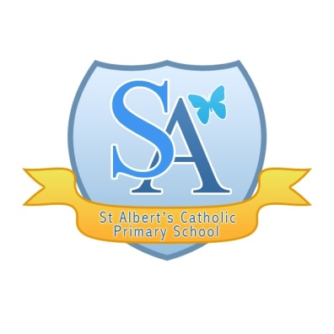
Health & Safety
STATEMENT OF INTENT

- To establish and maintain in so far as is reasonably practicable:
- an environment which is safe and without risk to health;
- safe working procedures among staff and pupils;
- health and safety arrangements for the handling, storage and transport of articles and substances;
- safe means of access to and egress from the school.
  - To ensure, so far as is reasonably practicable, the provision of information, instruction training, and supervision to enable all staff and pupils to avoid hazards and contribute positively to their own health and safety.
  - To teach safety, where appropriate, as part of the curriculum.
  - To formulate effective procedures for use in the case of an accident.
  - To lay down procedures to be followed in the case of an accident.
  - To provide and maintain, so far as is reasonably practicable, adequate welfare facilities for staff and pupils.
  - To provide effective systems of reporting and recording accidents, dangerous occurrences and potential hazards to health and safety.

Date adopted by governing body - 26th September 2018

Chair of Governors Fr. David Potter

Headteacher – Mrs Lorraine McEvoy

Signed ______________________ Chair of Governors

