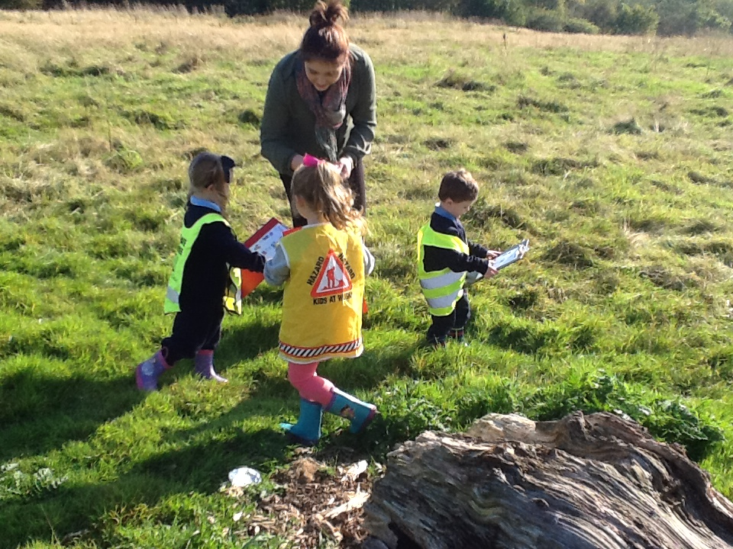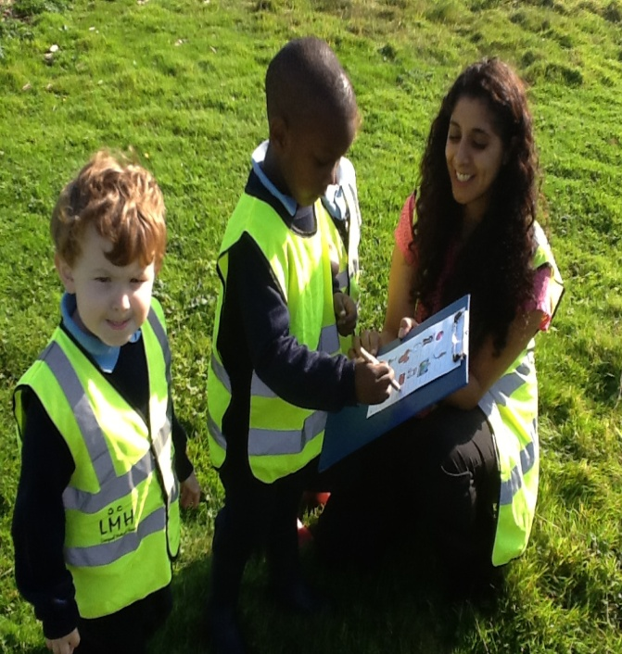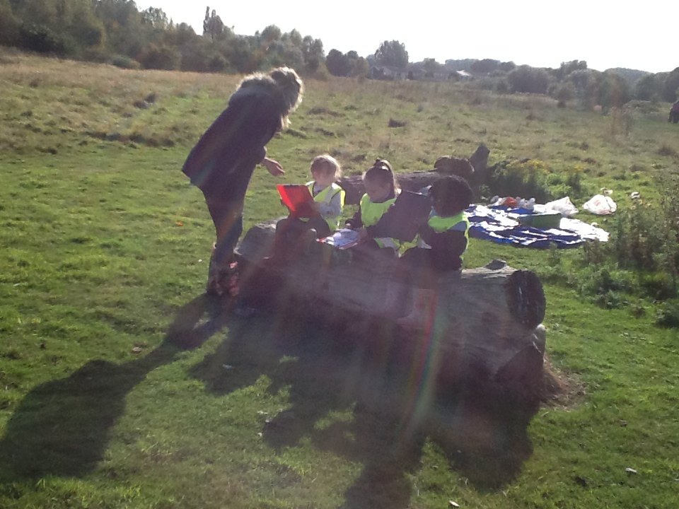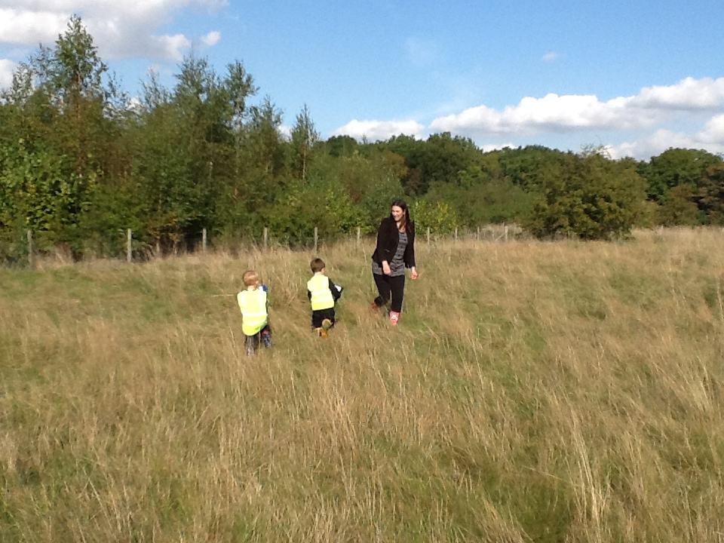

**After exploring our sense of sight and touch, we decided to explore our sense of hearing further. We were very grown up and sensible as we took responsibility of holding a clip board and pencil, which we used to mark our activity sheets. We went in our groups on a short walk; some of us remained seated to listen out to the sounds created in our surroundings. We marked all the sounds we could hear by putting a squiggle next to a picture that we thought made the sound. Some of the pictures were tricky and could not be found in the woods; however we heard extra sounds that were not even on our activity sheet. We heard ‘the rustling of paper, blowing in the wind’ a ‘car/house alarm’ and even a ‘leaping frog’**

**Next time we would like to see and hear squirrels looking for nuts and hedgehogs burrowing in the ground. We really enjoyed using our 5 senses and we are really lucky to have them!**