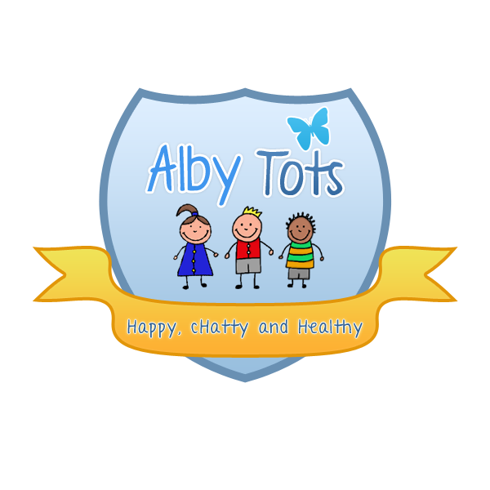
St Albert’s Catholic Primary School : Alby Tots
Transition Policy

Transition should be seen as a process, not an event and should be planned for and
discussed with children and parents (EYFS P10)

Settling In
• Home Visits are offered to all children and their families due to start at Nursery.
• The child’s key person will attend the visit.
• Information gathered at home visits and from 'About Me’ sheets will be used to aid planning for the child’s first visit.
• Every transition is unique based upon the child and their parent’s needs.
• Some children find transition easy, others do not, and a gradual process is generally adopted, where initial visits with parents are lengthened over time, gradually increasing the time the child spends in their room without their parents.
This is flexible depending upon how both the children and the parents react to transition.
• Start dates are staggered to ensure that new children have the opportunity to settle with their staff.
• Practitioners must also support parents during transition, letting them know how their child is settling and providing feedback throughout.
• Where required practitioners may provide transition aids for the use of the parent and child, or the child may have their own transition item i.e. a cuddly toy.
Daily Transitions
• Daily transitions are few at Broomhall due to the continuous provision used throughout the setting.
• Where transitions take place they are aided by giving the children options and where necessary aids such as rebus symbols or pictures.
Transition to School Nursery and other settings
• The setting will provide opportunities for teachers to visit the children in nursery and for children to visit their new schools where possible.
• Key persons are responsible for completing and passing on the transition documents to the new school.
Transitional Aids
• A number of schemes to aid transition are employed.
• Workshops for parents where they can be supported to help their child through transition into nursery, within the nursery and finally on to school.
• ‘All about me’ bags and boxes that children can fill with special possessions that mean something to them. Also a “passport to nursery/school” will be filled in for each child.

Signed: R. Henderson Date: September 2014

