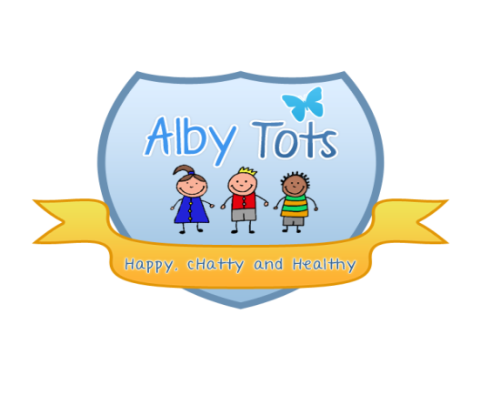
St Albert’s Catholic Primary School
Personal Possessions Policy

The nursery provides a wide range of toys and activities for all the children, catering for different needs, abilities and ages. Whilst it is not necessary for children to bring additional toys with them to play with, the nursery appreciates that sometimes a child may have a particular comfort toy that they wish to bring or a toy that they have been playing with just before they left home.
Staff will endeavour to keep all children’s toys and resources safe, however we are sure you appreciate that with several children in our care at any one time, it is not always possible to keep an eye on their belongings. Whist losses are rare we would advise that if a toy is very special or expensive that it remains safely at home as the nursery will not be held responsible for loss or damage to them. We would ask you to put your child’s name on it so it can be identified if found.
If your child does have a comfort toy that they are very attached to, the nursery recommends that additional 'copies' are purchased as this can prevent great upset if it becomes lost or that it does not come into nursery.
We would also ask that all shoes, boots, coats, jumpers etc… are all clearly named. With some many children at nursery at any one time it’s normal for several children to have the same items and it very difficult to make sure that they all have their own.
Signed: R.Henderson
Date: September 2014

