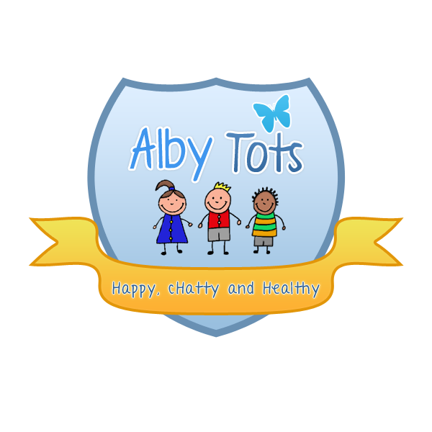

St Albert’s Catholic Primary school: Alby Tots
Equipment and Resources Policy

Statement of intent
We believe that high quality care and education is promoted by providing children with safe, clean, attractive, age and stage appropriate resources, toys and equipment.
Aim
We aim to provide children with resources and equipment which help to consolidate and extend their knowledge, skills and interests and comply with health and safety legislation and early years foundation stage frameworks.
Methods
We provide play equipment and resources which are safe and conform to the BSEN safety standards or Toys (safety) Regulation Act 1995. All portable electrical equipment is checked by a qualified engineer annually. We check all resources and equipment regularly as they are set out at the beginning and at the end of each session. We repair and clean, or replace any unsafe, worn out, dirty or damaged equipment. We hold a maintenance calendar and record the dates of cleaning, checking the resources and equipment. Risk assessment cards are produced for all equipment and are made available to all staff, students and volunteers.
We provide a sufficient quantity of equipment and resources for the number of children. We provide furniture that is suitable for all children. We store and display a selection of resources in locations where children can independently choose and select them. We provide play equipment and resources that promote continuity and progression, provide sufficient challenge and meet the needs and interests of the children. We provide man made, natural and recycled materials that are in clean, good condition and safe for the children to use.
We keep an inventory of resources and equipment. We use the inventory to review the balance of resources and equipment so that they can support a range of activities across all areas of play, learning and development. We provide appropriate insurance cover for the pre-school’s resources and equipment.
We select books, equipment and resources that promote positive images of people of all races, cultures and abilities, are non-discriminatory and avoid racial and gender stereotyping. We would seek help from either Early Years Advisors or Area SENCO for advice on supporting children with additional needs and accessing specialist equipment or resources.
We use local library and resource centres to introduce new books and a variety of resources to support children’s interest. We use Scrap Stores for a range of intelligent materials to encourage creative play.
The daily provision offers a balanced variety of familiar equipment and resources. A wide range of other equipment and resources is rotated to ensure all children have the opportunity to access and explore. We enhance provision depending on the children’s interests which helps extend their knowledge and developing skills. We offer exciting equipment and resources, which offer challenges that, are achievable and are suitable for all children. These methods apply to both indoor and outdoor play.
Signed R. Henderson
Date: September 2014

