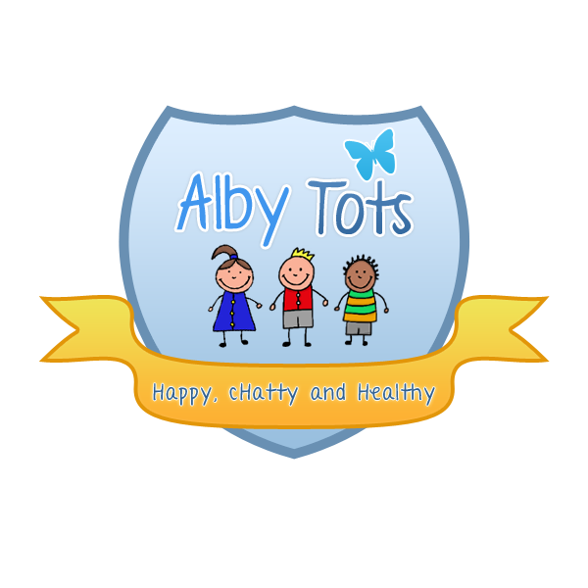
St Albert’s Catholic Primary School: Alby Tots
Biting -policy and procedure

Children flourish best in a secure environment and are entitled to learn and develop without fear or intimidation from peers or adults.
Aims
1. To ensure that strategies used are consistent between all staff and areas of the nursery
2. Offer reassurance to parents that staff are competent in handling situations of conflict
3. To reduce trauma for the child or person that has been bitten
4. To provide accurate information to parent’s regarding when to seek medical advice
5. To maintain accurate records and effective communication systems
A) For the child who receives a bite:

Lead adult to comfort the child, assess the injury and take appropriate action.
The lead adult to assess the severity of the injury and make a decision whether to inform parent’s immediately.
If skin is broken parents’ are to be contacted and informed that they should seek medical advice.
Accident form to be completed by lead adult.
Visual prompt symbol to be displayed so that all staff are aware parent’s signature is required.
Child will be given time to recover, staff will observe and monitor for short period of time afterwards.
Parent to sign the accident record at the end of the session.

B) For the perpetrator:

2nd adult to remove child from the situation and explain to the child why their behaviour is not acceptable, in a way that is age and developmentally appropriate.
Child will sit quietly with adult for time out, the length of which will be determined by the child’s chronological age or development.

After the quiet period had ended, the child will then be encouraged to engage in play or activities available, the key person will continue to observe and monitor for short period of time afterwards.
Incident record to be completed by lead adult during the session that the incident occurred.
If a pattern of continued behaviour is identified in the perpetrator, the child’s key person will work in partnership with SENCO and parent’s to discuss techniques in managing their behaviour. Advice may also be sought from external agencies if deemed appropriate.

C) For an adult who receives a bite:
1st Aid to be administrated by qualified member of staff, applying the same procedure for seeking medical advice as in section (A).
Adult to be given time to recover away from the room if required.
Accident form to be completed and Manager informed.
Signed R. Henderson EYFS manager
Date September 2014

