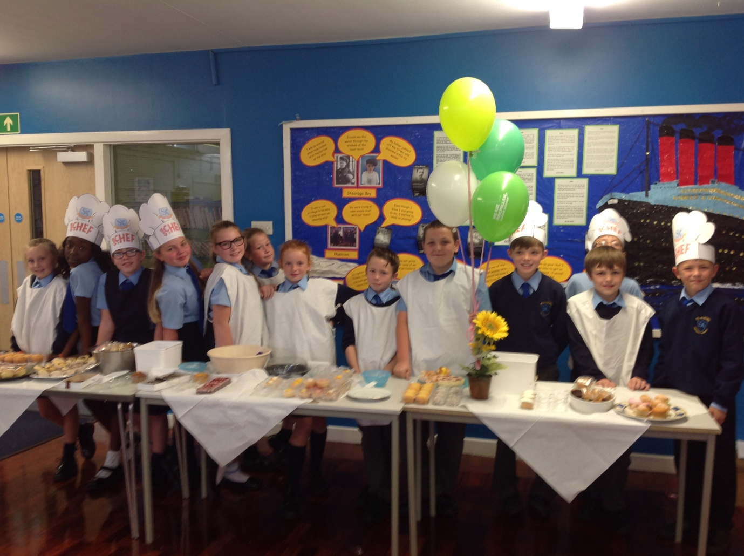

Thank you to all the children, parents and staff who joined in with our coffee morning last week in aid of MacMillan Cancer Care. We managed to raise £230 in school! Our contribution was added to other local events in Stockbridge Village and together we managed to raise £1424.09! Well done Year 6 and Mrs Ellis!

