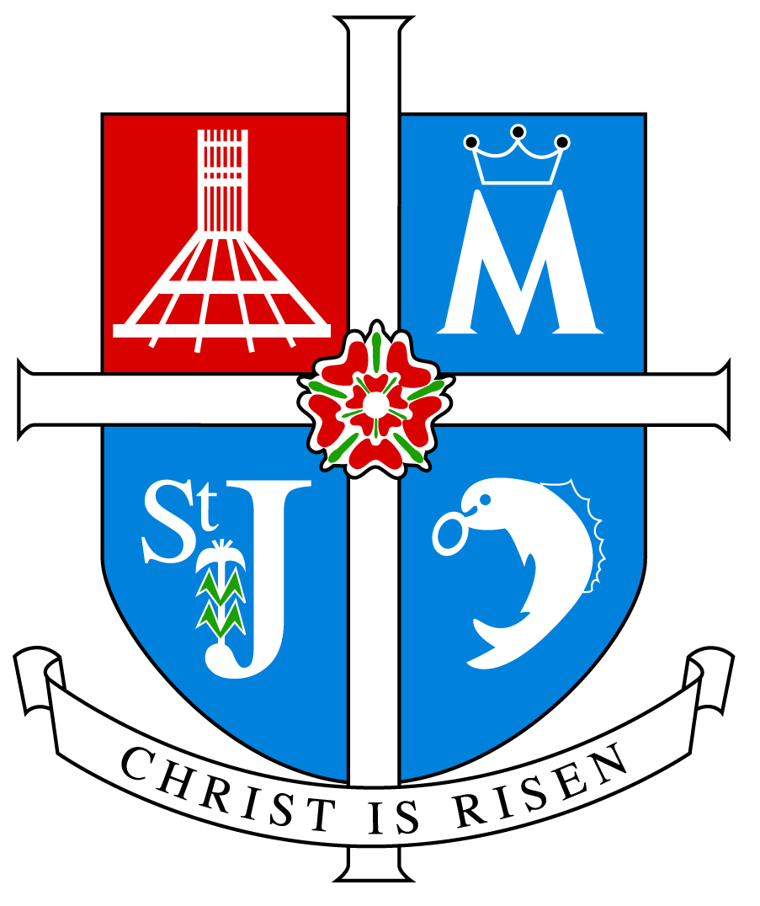

ARCHDIOCESE OF LIVERPOOL

INSPECTION REPORT

ST ALBERT’S CATHOLIC PRIMARY SCHOOL

KNOWSLEY

Inspection Date Tuesday 1 May 2012

Inspectors Miss Julie Lockett Mrs Meg Buckley

Unique Reference Number 104467

Inspection carried out under Section 48 of the Education Act 2005
_________________________________________________________________

Type of School Catholic Primary

Age range of pupils 3 - 11

Number on roll 179

Chair of Governors Mr Chris O’Connor

Executive Head teacher Mrs Rachael Tyler

Associate Head teacher Mrs Lorraine McEvoy

School address Steers Croft
Stockbridge Village
Liverpool
L28 8AJ

Telephone number 0151 477 8560

E-mail address stalbert@knowsley.gov.uk

Date of last inspection 13 March 2007

Introduction

This inspection was carried out under Section 48 of the Education Act 2005.

The report of the inspection is produced for the Archbishop of Liverpool (Code of Canon Law 804 and 806) and for the governors of the school.

The inspectors are members of the Christian Education Department and their associates approved by the Archbishop of Liverpool for this purpose.

Information about the school

St. Albert’s is a smaller than average sized Catholic Primary School situated in Stockbridge Village, Knowsley. The school mainly serves the parish of St. Albert’s and a smaller number to the parish of St. Timothy’s. There are 133 children on roll of whom 98 are baptised Catholic, 24 children come from other Christian denominations, and 11 are from other faith or religious traditions. St Albert’s has a growing number of pupils from minority ethnic backgrounds. The proportion of pupils with special educational needs is above average. Almost half of the pupils are known to be eligible for free school meals. There are 11 teachers of whom 9 teach Religious Education, 10 are Catholic. Four teachers have a suitable qualification in Religious Education.

Since 2009 the school has worked closely in federation with St Brigid’s Catholic Primary School. There is a joint governing body for both schools. The associate headteacher is currently seconded to support the temporary executive head teacher in the running of St Albert’s. The school has appointed a new Religious Education coordinator who has been in post since September 2011.

Key for inspection grades

Grade 1 Outstanding
Grade 2 Good
Grade 3 Satisfactory
Grade 4 Inadequate
______________________________________________________________

© 2012 copyright – Archdiocese of Liverpool. This document may be reproduced in whole or in part for non-commercial educational purposes, provided that the information quoted is reproduced without adaptation and the source and date of publication are stated.

Further copies of this report are obtainable from the school.

Inspection Judgements

Overall effectiveness:
2
How effective the school is in providing Catholic Education
2
The school’s capacity for sustained improvement

Main Findings:-

The school is good overall in providing Catholic Education. There is a clear vision for Catholic Education which is embraced by the whole school community.
Since the last inspection the school has maintained and built on previously good performance. Self evaluation is rigorous and accurate. Outcomes for pupils are good. There is no significant difference in performance between groups of pupils. Outcomes for pupils with additional or special needs are good. The school is successful in addressing the areas it has identified for improvement. The leadership team is deeply motivated and consistently communicates its high expectations to staff in order to secure improvement. Staff are affirmed and supported. Teachers are provided with In-service to support their ongoing development. There are realistic and challenging action plans in place to move the school forward to improve outcomes.

Overall the school has good capacity for sustained improvement.

St Albert’s is a warm, safe and inviting place to be. The school is filled with display work that is given care, attention and reflects celebration of learning. The executive headteacher and associate headteachers’ vision is clear on building relationships, which is evident within St Albert’s and its surrounding community. The Parish Priest speaks highly about the Catholic life of the school, knowing that amongst the staff ‘there is great dignity and a great respect for all. There is practical forgiveness, they know how to deal with brokenness with warmth and affection, this happens day after day.’ This too is evident in the outstanding commitment through the many projects and activities for the community and reflects the schools mission. To achieve this staff adapt to suit the needs of the children, parents and local community. Working together to achieve this shows commitment, dedication and an example to others.

What the school needs to do to improve further

- Develop staff professionally by:
- attending Catholic Certificate in Religious Studies.
- Continue to develop timetabled monitoring of Religious Education in:
- planning, teaching and learning and workbooks.
- Moderation of formal assessments to:
- continue a portfolio of levelled work;
- show evidence of each formally assessed attainment target.

How good outcomes are for individuals and groups of pupils

Pupils’ achievements in Religious Education are good. On entry to school many children have a limited knowledge and understanding of the Catholic faith. Outcomes for pupils with additional or special needs are good. Pupils’ attainment in Religious Education is broadly average. When targeting the lower levels, analysis of assessments undertaken, provides evidence of pupils generally attaining appropriate level for their age and stage of development. They make good progress in relation to their starting points. Moderation of assessments would provide secure levels in knowledge and understanding, in particular for higher levels of attainment. Pupils are becoming increasingly more literate. Their knowledge, understanding and skills are developing. They are using skills that enable them to reflect spiritually, to think ethically and theologically and are becoming more aware of the demands of religious commitment in everyday life. Pupils’ enjoyment of their learning is good as shown by their interest, enthusiasm and behaviour. For example, very young children were observed enthusiastically listening to and speaking about the Holy Spirit. In the earliest years, the high standards in expected behaviour and creative teaching to interest children in their learning, gives pupils a strong foundation to build on.

Pupils at St Albert’s are actively involved in developing and evaluating the Catholic character of the school by living out part of their mission statement, ‘Serving the community in the love of Jesus Christ.’ Pupils have a good sense of belonging to the school community and value and respect others. They are considerate and caring of others both in school and the wider community. Pupils are encouraged to take on roles of responsibility in the school, for example, as eco monitors and school council members. Pupils are encouraged to make decisions that impact on the wider community, for example, fundraising for a Nigerian family via Nugent Care. Pupils benefit from participation in away days and retreat activities such as participation in the Mayor’s Award and Year 6 residential at a Robinwood Activity Centre. The quality of relationships between staff members is an example passed on so that pupils have a good sense of right and wrong and apply this in their personal relationships. There is extra support available from the schools’ learning mentor. Pupils take an increasing responsibility for themselves and their actions. This is evident through ‘Golden Values’, rules which the children know and live out daily. They praise and acknowledge the contribution of others through ‘Rejoice Celebrations’ and prize giving assemblies where they embrace and celebrate their experiences.

Pupils are good in responding to and participating in the school’s Collective Worship. They are developing skills in preparing and leading worship from their earliest years. Pupils’ knowledge of prayer and liturgy is increasing and they are familiar with a variety of prayer styles. Older pupils were keen to speak about their Collective Worship and they embrace the opportunities given to them to plan and present worship. Younger children observed were guided with focus on reverence and respectfulness. They appreciate and are open to the Word of God in the Scriptures. Pupils sing joyfully, reflect in silence and join in prayers appropriately and with confidence. They are inspired and encouraged to lead using very good examples on how to gather, listen, respond and go forth. Good examples set through planning and monitoring will continue to deepen and build on pupils’ response and participation. No-one is expected to act in a manner contrary to their beliefs and all show mutual respect.

How good outcomes are for individuals and groups of pupils
How well pupils achieve in Religious Education | 2
- pupils’ standards of attainment in Religious Education | 3
- the quality of pupils’ learning and their progress in  Religious Education | 2
The extent to which pupils contribute to and benefit from the Catholic Life of the school | 2
How well pupils respond to and participate in the school’s  Collective Worship | 2

How effective the provision is for Catholic Education

The quality of teaching is consistently effective in ensuring that pupils are interested and engaged and make good progress. Teachers take into account pupils’ prior learning and are developing differentiated tasks when planning so that the work consolidates, builds and extends their knowledge and understanding. Teachers provide good opportunities for pupils to work independently and collaboratively, such as talking partners. Good use is made of time and resources, for example, pupils use of God’s Story and sound resources used to re-enact the coming of the Holy Spirit. Resources used and made within lessons were of a high quality. Teachers and teaching assistants use a variety of strategies to sustain and motivate pupils. For example, Information Communication Technology was used well to aid children in their learning objectives and to share understanding through power point presentations. Focused questions and discussions for older children led to deeper understanding of Scripture and challenged more able children. Teaching assistants provide excellent support to groups and individuals and aid pupils throughout lessons. Pupils’ are constantly praised and they are informed of their progress orally. They are given opportunities to reflect and discuss their work, particularly from prior learning within the introduction phase of lessons.

The assessment of pupils’ work in Religious Education is satisfactory. The school has broadly accurate assessment strategies which provide information on the achievement of all the pupils. There is some good use of assessment for learning observed throughout lessons and in workbooks. Recording in books matches the Religious Education programme and has some variety. There is encouraging marking. A whole school approach to enable pupils to assess their learning within religious education lessons and workbooks will provide pupils with understanding of how they can improve their learning. Formal assessment tasks are undertaken in line with Archdiocesan guidance. Assessment information is collated by the subject leader and shared with the leadership team, governors and parents. Formal reporting to parents is detailed and achievement and effort are celebrated.

The curriculum is good in meeting pupils’ needs. The school using the Here I Am programme recommended by the Archdiocese meets the requirements of the Curriculum Directory for Religious Education. A whole school approach is used and appropriate levels of the programme are being followed in different classes. This ensures complete Religious Education entitlement for each child and meets National and Archdiocesan requirements. Of the total curriculum time 10% is allocated to Religious Education. This fulfils the requirements of the Bishops of England and Wales. Planning ensures full coverage of the Religious Education programme. There is evidence of creative, imaginative strategies planned for pupils learning. Through the use of the new Religious Education programme, ‘Come and See,’ staff will have the opportunity to plan using driver words and differentiation in more detail. Curriculum outlines are provided for parents who are consulted on different issues depending on the topic being covered. The school implements new curriculum developments as appropriate. St Albert’s provides pupils with a skills based, topic curriculum with Religious Education embedded within. Enrichment activities such as ‘Forest Schools’ provides outdoor experiences within their immediate environment, ‘First News’ a newspaper produced by the pupils and a range of after school clubs have a positive impact on the curriculum. The Religious Education curriculum provides good opportunities for pupils’ spiritual and moral development, for example, ‘Relax Kids,’ supporting pupils through meditation activities. The schools’ learning mentor provides invaluable care to families and pupils, raising pupils’ potential and positive communication with families.

The Collective Worship provided is good in reflecting the Catholic character of the school and taking into account all faith backgrounds among the pupils. Collective Worship plays a key part in meeting the spiritual needs of the pupils. Children are enabled to pray formally and informally. The school provides opportunities for staff to develop the skills in planning and leading Collective Worship. Themes are planned for throughout the year. The school has provided staff with Collective Worship training and the subject leader is guiding improvements in planning, preparation and delivery and has plans in place to develop monitoring. The teachers provide the necessary resources and opportunities to help children to develop the skills necessary to plan, lead and participate in Collective Worship. There are prayerful, reflective and inspiring displays and focus areas throughout the school. Opportunities are provided for parents, carers the local and wider faith communities to participate in a variety of celebrations of the ‘Here I Am’ programme and the Church’s liturgical year. For example, ‘Rejoice’ assemblies, participation in masses in St Albert’s Parish church and Stations of the Cross. Parish members of the Legion of Mary regularly attend school and lead pupils and staff in prayer.

How effective the provision is for Catholic Education
The quality of teaching and purposeful learning in Religious Education | 2
The effectiveness of assessment in Religious Education | 3
The extent to which the Religious Education curriculum meets pupils’ needs | 2
The quality of Collective Worship provided by the school | 2
How effective leaders and managers are in developing the Catholic Life of the school

Leaders and managers are good in promoting and developing the Catholic life of the school and show a good understanding of and commitment to the Mission of the Church. This is reflected in the Schools own Mission Statement, ‘Educating children, serving the community, in the love of Jesus Christ’. All who form part of the school community including parents, Priests, governors and children were involved in the development of the current Mission Statement. Its aims and practical objectives direct and guide every aspect of school life and are a useful tool by which the school evaluates its effectiveness. The associate headteacher is committed to the distinctive mission of the school and has a clear vision for its future. Action plans are in place to review the schools’ Mission Statement as part of the federated approach for both St Albert’s and St Brigid’s. The Self Evaluation Document provides evidence of the schools monitoring, searching analysis and self challenge. The analysis provides a basis to celebrate the schools strengths and outlines areas for development. There are good action plans in place and the associate headteacher prioritises them effectively. The school provides good induction and in-service training to enable staff to further understand the Church’s Mission in Education and play their unique part in it. The associate headteacher attends relevant Archdiocesan training. Topic days provided by Christian Education are attended. A small number of teaching staff have a Catholic Certificate in Religious Education, attendance for other members of staff to undertake the course are within the schools action plans. Themes throughout the school year, such as ‘Olympic Values’ provide opportunities for Spiritual and Moral development for staff and pupils. This enables the school family to be an example to the wider community in living out their mission. There are plans in place for staff to develop reflection time prior to topics taught in the Religious Education Programme.

Leaders and managers are good in the way they use monitoring data to evaluate the schools performance, celebrate, and plan future improvements. There are good action plans in place that show the strengths of the school and clear areas for development. These are reported on to governors. This is evident when identifying appropriate targets in the self evaluation document. The associate head teacher, working closely with the subject leader, has plans in place to specifically target monitoring of religious education planning, teaching and learning and children’s work. Good systems for tracking have been introduced showing some data for Religious Education targets. The newly appointed Religious Education coordinator has enthusiasm and vision for her role. She shows commitment to the Catholic life of the school and community, for example, volunteering to support St Albert’s links with a pilgrimage to Lourdes. She is at the initial stages of guiding Religious Education and introduces new initiatives when appropriate. The subject leader attends all relevant Archdiocesan training and is fully supported in her role by the previous subject coordinator. There are comprehensive policies in place and this good documentation guides and directs all staff in the delivery of the subject.

Governors are good in fulfilling their responsibilities. Governors are aware of any implementations and standards achieved. They are aware of and fully supportive of the action plans of the associate headteacher, necessary to bring about improvements. There is an effective healthy budget for Religious Education. Policies are reviewed yearly. The chair of governors leads with passion and understanding about the school and its community and is very committed to shaping the direction for St Albert’s. He provides consistent time and support to staff and pupils in the weekly life of the school. The Governors work closely with the school in partnership with parish members and promote St Albert’s as an inclusive fellow Christian community.

Parents are consulted regularly and involved in a variety of ways in the life of the school. Feedback from the parents’ questionnaires showed a high percentage strongly agreeing with views on the Catholic life and Religious Education at St Albert’s. Parents are regularly welcomed to school through regular parent coffee mornings and ‘Rejoice’ assemblies’. Information for parents is sent via termly and weekly newsletters and school website updates. Parents are warmly welcomed to be a part of the ‘Friends of St Albert’s’ group.

Leadership at all levels respects difference, values diversity and ensures equal opportunities for all. Prayer, worship and the liturgical life of the school reflects and respects the religious diversity within the school. There are positive relationships at every level within the school. There are numerous opportunities provided for the staff and pupils to play an active part in Catholic life and Mission of the school. St Albert’s has an outstanding commitment to community cohesion. Leaders and managers facilitate pupils’ involvement in service to the local faith and religious communities. The school has strong links with Handicapped Children's Pilgrimage Trust. The trust is supported by St Albert’s school staff and governor volunteer members. St Albert’s has growing multi cultural numbers and the school actively seeks to learn and celebrate diversity. The schools’ learning mentor is directed to work with partners reflecting the change in ethnic characteristics of the school and there is a coordinator for ethnicity. St Albert’s annual ‘Multi Cultural Week’, for example, focused on Nigeria. Nigerian families from the school community hosted cookery sessions, talks about their culture and held a Baptist choir session. Dialogue and collaboration of all in the local and wider community is encouraged, celebrated and tolerant and is a real strength of St Albert’s school. This exemplary attitude is then reflected in partnerships reaching out globally, for example, CAFOD social justice sporting events. The immediate neighbourhood is served by the school through involvement with, for example, ‘Stockbridge Family Group’ looking at factors affecting the learning lives and families in the community. The school plays an active part in ‘Me, Us and You’ a community project involving Stockbridge, Africa and the Olympics, where activities are based on the Global Family. The use of the ‘Here I Am’ programme promotes community cohesion by using topics to develop themes in for example, ‘circle time’ and social and emotional aspects of the curriculum. The ‘Here I Am’ topics aids approaches to respecting and valuing difference. Children have explored the beliefs and values of other faiths and religions, for example, visiting other places of worship and inviting a member of the Jewish community sharing aspects of Jewish faith. This helps to promote tolerance and respect for those who think differently. The review of the Mission Statement will be an opportunity to highlight the outstanding examples of ‘serving the community’ St Albert’s is achieving.

How effective leaders and managers are in developing the
Catholic Life of the School
How well leaders and managers promote, monitor and evaluate the provision for the Catholic Life of the school and plan and implement improvement to outcomes for pupils | 2
How well leaders and managers monitor and evaluate the provision for Religious Education and plan and implement improvement to outcomes for pupils | 2
The extent to which the governing body provides effective challenge and support for the Catholic dimension of the school so areas needing development are addressed decisively and responsibilities met | 2
How effectively leaders and managers promote community cohesion | 1

