Spiritual, Moral, Social and Cultural Policy

SMSC

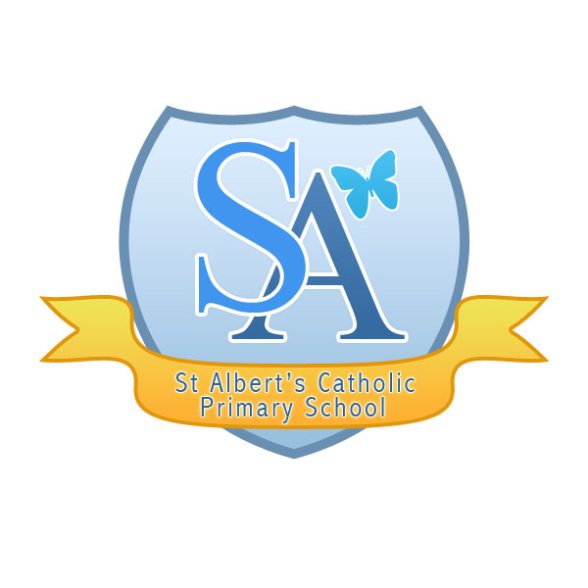

MISSION STATEMENT

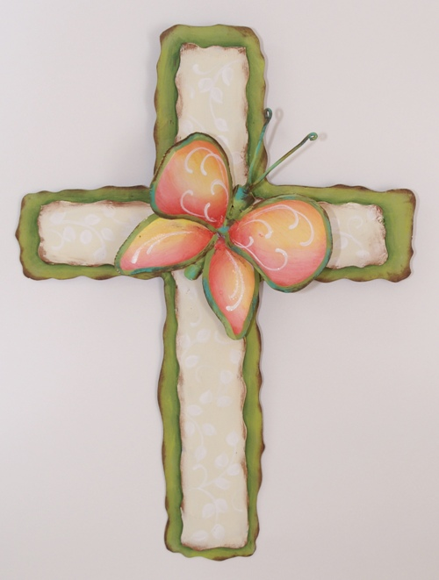

Educating the children and serving the community, in the love of Jesus Christ

Introduction

The promotion of pupils’ spiritual, moral, social and cultural development provides the ‘why’ of education: it is an essential ingredient of a successful Catholic school. Spiritual, Moral, Social and Cultural Development is at the heart of what education is all about – helping pupils grow and develop as people.

At St Albert’s School we want our pupils to be successful, confident learners and responsible citizens. We recognise the importance of both the academic and personal development and well being of every child in our school. This includes recognising the importance of providing a range of opportunities for our pupils to respond to, that supports their spiritual, moral, social and cultural development with an understanding and an overview of the Every Child Matters agenda.

Aims

- promote the spiritual, moral, cultural, mental and physical development of pupils at the school and in society, and
- prepare such pupils for the opportunities, responsibilities and experiences of adult life.’
- provide an appropriate range of effective teaching and learning strategies that enable pupils to reflect on and respond to the issues of SMSC importance and concern
- maintain a positive climate in school in which all are valued and respected and expected to make a positive contribution
- encourage teachers to plan for and respond to opportunities to develop SMSC development
- to ensure subject leader have an understanding of SMSC education in their subject
- recognise the importance of our collective worship programme in supporting and encouraging SMSC development

Opportunities

It is an expectation that all staff, in all subjects, can and should, make a contribution to the Spiritual, Moral, Social and Cultural Development of pupils through the taught curriculum and through the use of appropriate teaching and learning strategies e.g. discussion, reflection, pupil participation, circle time etc.

It is also recognised that Spiritual, Moral, Social and Cultural Development can be taught as a standalone. Each term a calendar of organised opportunities will be drawn up. This can be viewed by Parents on the school website.

Spiritual, Moral, Social; and Cultural development (SMSC)
(NB whilst each dimension is outlined separately there is a great deal of overlap between the four areas).

Spiritual Development
‘to be human is to be spiritual since human beings are more than the purely physical’.

Spiritual education helps pupils to acquire insights into their personal existence which are of enduring worth. It is characterised by reflection, the attribution of meaning to experience, valuing a non-material dimension to life and intimations of an enduring reality. “Spiritual’ means ‘of the spirit’. Spiritual development, therefore, concerns the development of the essence of a unique child. In the Catholic tradition, spiritual development is related to growth in faith. However, Spiritual is not synonymous with ‘religious’; all areas of the curriculum may contribute to pupils’ spiritual development.

Spiritual development is concerned with how an individual acquires personal beliefs and values, especially on questions which are “at the heart and root of existence.” It is, therefore, also about what a school provides – through its curriculum, through Collective Worship, through its ethos and climate – to help individuals to make sense of these questions and about what it does to help form pupils’ response to life, to their various experiences and even to questions about the universe. Spiritual is very much at the heart of life.

As a Catholic school, St Albert’s aims to provide a set of values based on the Christian faith. Central to the Christian teaching is the love of God and the love of one’s neighbour as oneself. We include Christian spiritual practices including prayer, worship, celebration of festivals and reading/reflection on the Bible within Collective Worship, RE and the wider curriculum.

We are committed to:
- celebrating the religious and non-religious beliefs and values that our pupils bring as part of their family/cultural heritage and to building an awareness of and respect for others’ spiritual and religious beliefs
- fostering common human values and building spiritual capacities to promote self-worth
- self-esteem and a valuing of others
- helping our pupils to come to an understanding of themselves as unique individuals and encouraging them to reflect on ultimate questions
- developing our pupils’ curiosity, imagination, creativity and promoting a sense of awe and wonder.

Spiritual Development is promoted throughout the whole curriculum by providing pupils with opportunities and encouragement to:

- Reflect on themselves, others and life’s fundamental questions (Here I Am, literacy, science, PSHE)

- Exercise intellectual curiosity – testing their beliefs against others’ and exploring sameness and differences (study of other faiths, geography, history)

- Study and discuss – the insights of the great teachers and philosophers

- Experience awe and wonder – to be moved by nature and by excellence in human achievement.

- Exercise imagination and intuition – in creative pursuits and in forming theories in their academic work and daily life.

- Discuss and debate – insights, beliefs, ideas, emotions, feelings and experiences (Come and See, circle time, PSHE)

- Reflect and respond to God’s presence in prayer, worship, reflection and during Sacramental preparation.

The development of children spiritually implies that this is an area in which they can make progress. This may not be linear but may include the following steps:

  - Recognising the existence of others as independent from themselves.

  - Becoming aware of and reflecting on experience.

  - Questioning and exploring the meaning of experience.

  - Understanding and evaluating a range of possible responses and interpretations.

  - Developing personal views and insights.

  - Applying insights gained with increasing degrees of perception to one’s own life.

  - Personal response to questions about the purpose of life and to the experience of beauty, love, pain or suffering.

Moral Development
‘knowing what is right and wrong and acting on it accordingly’.

Moral Development is about the building, by pupils, of a framework of moral values which regulates personal behaviour. It is about the development of pupils’ understanding of society’s shared and agreed values. All adults in the school are aware that children learn by example. All adults, therefore, aim to demonstrate respect in their relationships with each other and with the children in their care. This is demonstrated informally through daily interactions with colleagues and pupils.

Moral education helps pupils to acquire knowledge, understanding, intentions, attitudes and behaviour in relation to what is right or wrong.

Moral development is concerned with understanding the difference between right and wrong and with committing ourselves to doing what is right because we want to do right.

People who are developing morally listen to their conscience, the inner sense informed by their upbringing, experiences, faith and religious beliefs and are prompted to do what is right out of love for others, respect for ourselves and regard for the world in which we live.

Moral Development in our school is promoted throughout the whole curriculum and expressed in our values. Pupils are provided with opportunities and encouragement to:

- think critically – understanding the difference between fact and opinion, informing themselves about key social, political, economic and legal issues, evaluating evidence for and against different sides in a debate and making informed decision about their own positions (literacy, citizenship, history)

- acquire and develop appropriate values and attitudes – those that enhance willingness to participate and help others to participate where necessary

- discuss and debate – exercise reason in debate and develop an understanding of the powerful influences on public opinion represented by the political parties, the church and other faith communities, the media and other organisations.

- Participate in democratic processes such as school councils, committees and discussion groups.

- Participate in the life of the wider community through volunteering and charity work.

We are committed to encouraging our pupils to:
- be truthful and honest
- respect the rights and property of others, their opinions and customs, even when they are different from our own
- help others
- solve differences of opinion in non-violent ways
- Consequently we reject all forms of bullying, cruelty, dishonesty, violence and discrimination

St Albert’s is dedicated to enabling all members of our school community to grow in faith through a deepening knowledge of creation and revelation and to live that faith within our school community, at home, in the parish and in the wider world.

Social Development
‘developing an understanding of rights and responsibilities of living in community-of being a ‘responsible citizen’.

We are committed to:
- fostering the skill and qualities of team building through the development of self-confidence, co-operation, sensitivity to others, reliability, initiative and understanding
- providing an environment where pupils can take responsibility for themselves and others in school and the wider society
- Teaching the children how to successfully participate in the school community, the local community, nationally and internationally.
- Teaching the children learn to be tolerant to all the people in society.

We use the social and emotion aspects of learning (SEAL) programme to support our pupils’ social development

Cultural development
‘knowledge and understanding of own and others’ cultural traditions’.

At St Albert’s we value and celebrate the cultural diversity of our school, our society and the world by:
- promoting an appreciation of our own cultural tradition/s and encouraging an appreciation of other people’s cultural traditions
- celebrating the richness of culture and tradition.
- providing an appropriate range of effective teaching and learning strategies that enable pupils to reflect on and respond to the issues of SMSC importance and concern
- maintain a positive climate in school in which all are valued and respected and expected to make a positive contribution
- encouraging teachers to plan for and respond to opportunities to development SMSC development and to ensure subject leader have an understanding of SMSC education in their subject
- recognising the importance of our collective worship programme in supporting and encouraging SMSC development
- reviewing the effectiveness and impact of our policy and practice as part of our cycle of school development

This Policy should be read in conjunction with the School Mission Statement, Behaviour Policy, the RE Handbook and the ‘Come and See’ scheme.
The following policies are closely linked with our spiritual, moral, social and cultural policy:
- School Aims
- Inclusion/Equal Opportunity Policy
- Collective Worship Policy
- Subject area policies especially, but not exclusively, RE, PSHE

